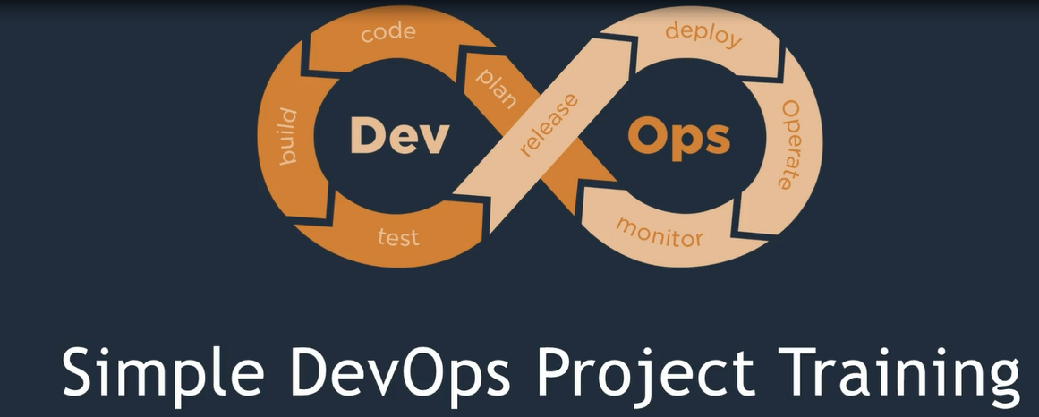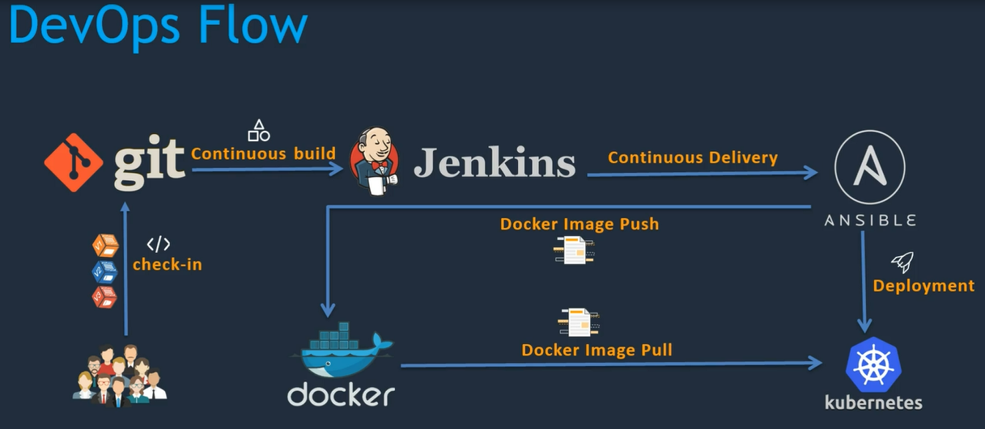

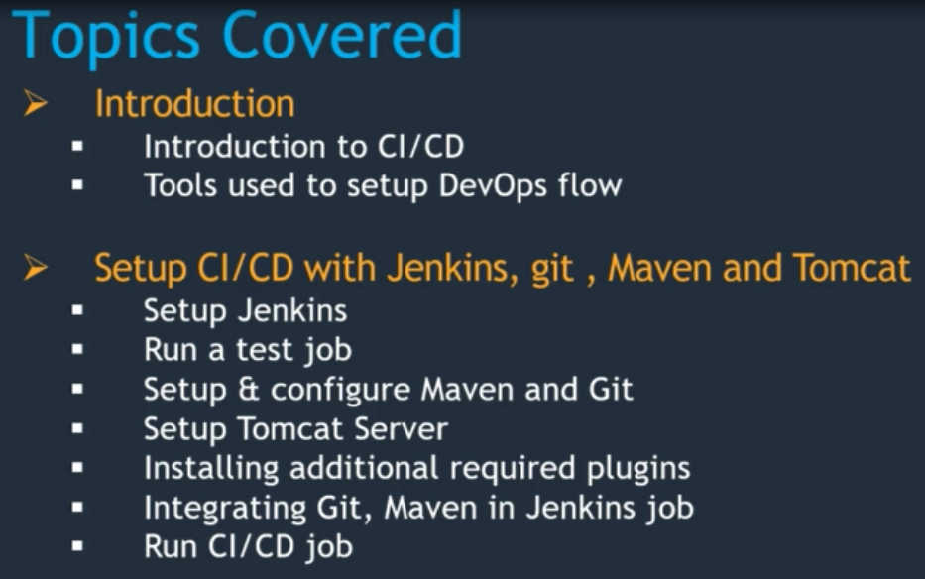

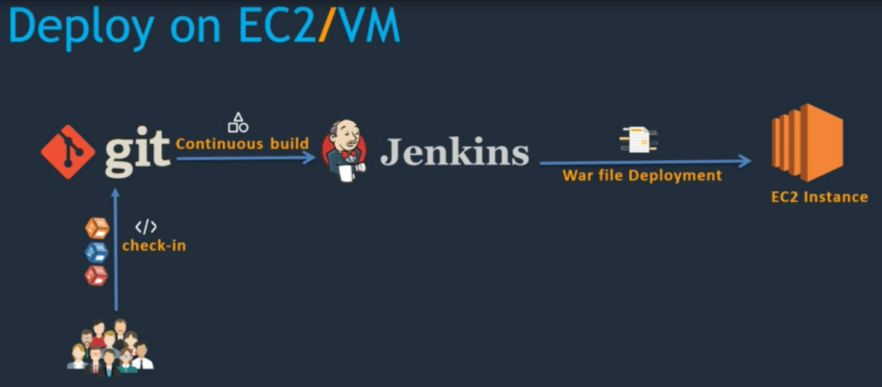

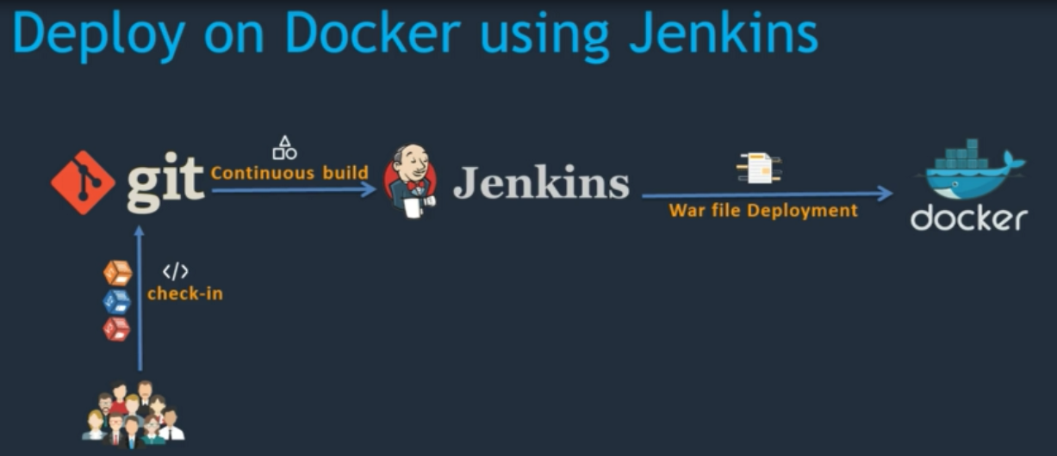

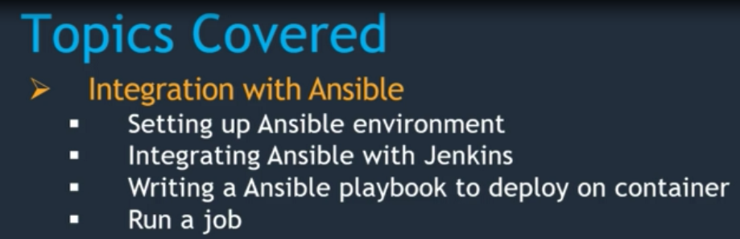

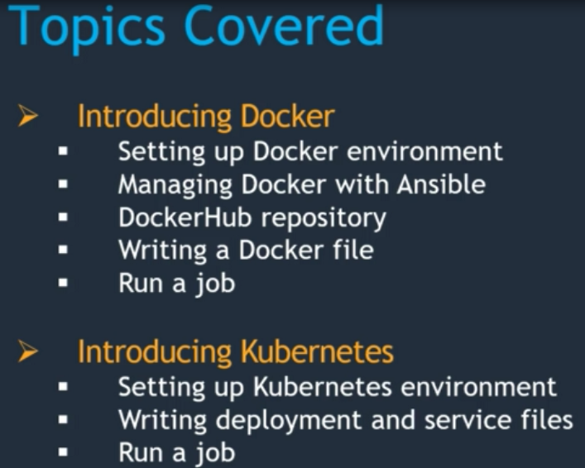

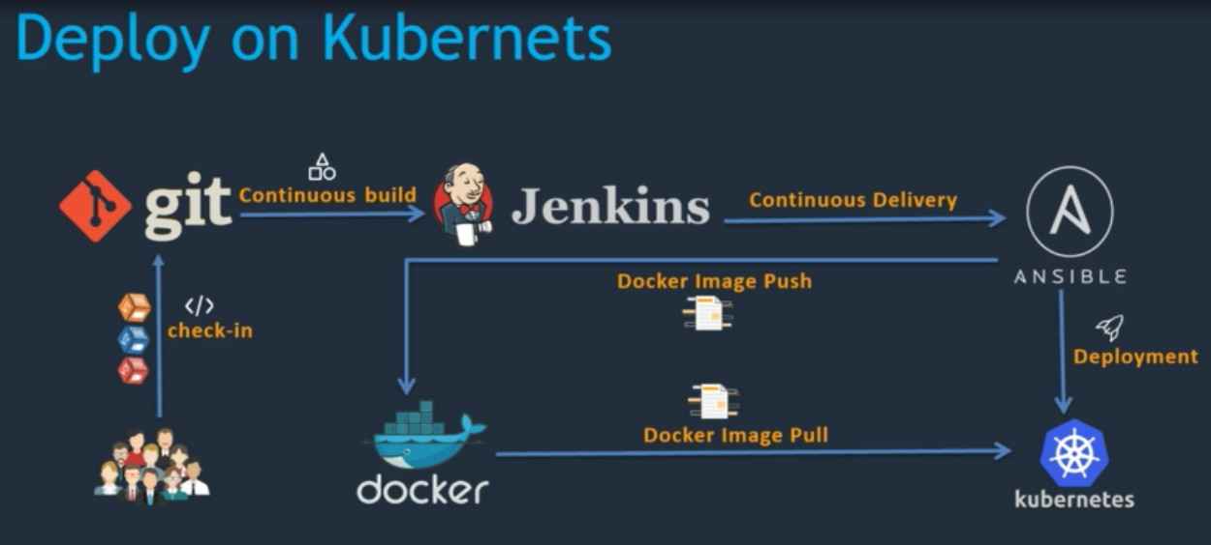

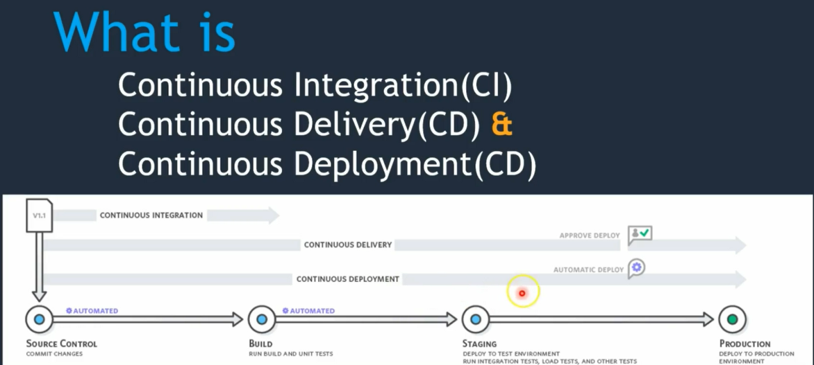

Resources before starting. Please clone below Github repositories before starting this course.

https://github.com/yankils/hello-world

https://github.com/yankils/Simple-DevOps-Project

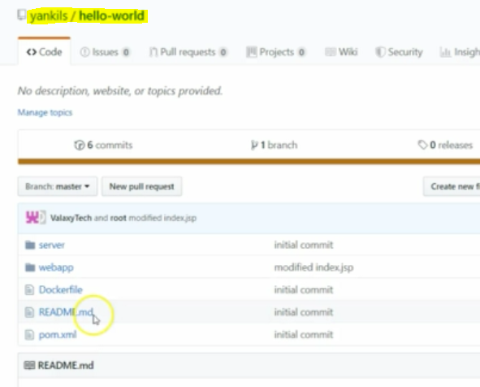

To Install Jenkins will be useful below scripts

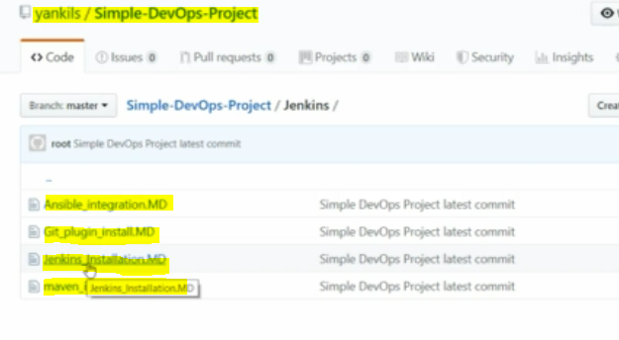

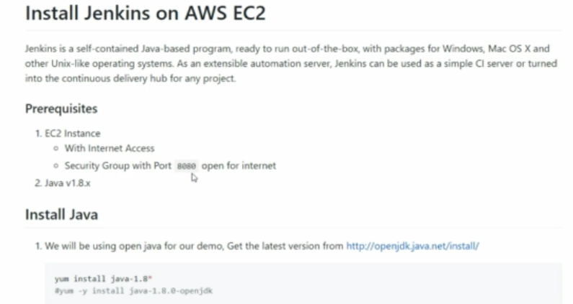

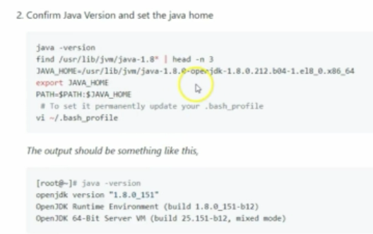

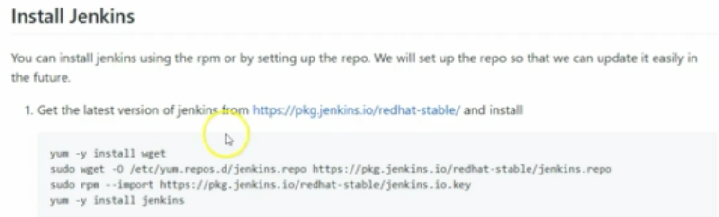

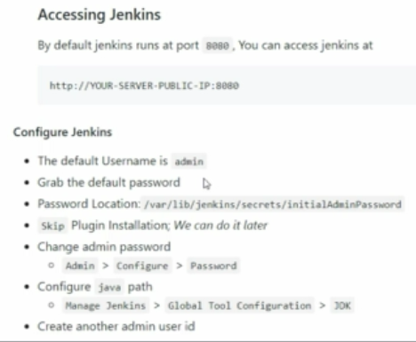

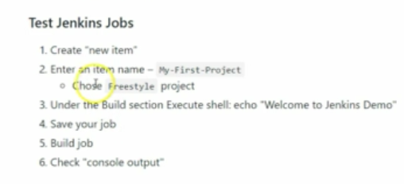

Create new EC2 instances and with Linux server and the below ports should be opened for the Jenkins server.

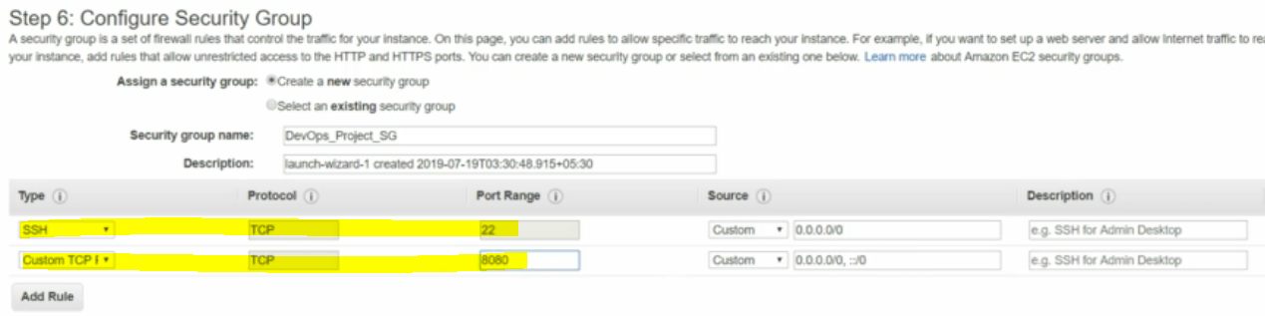

Login with iP address for the Jenkins server

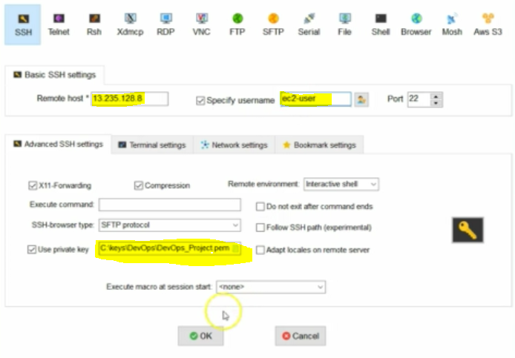

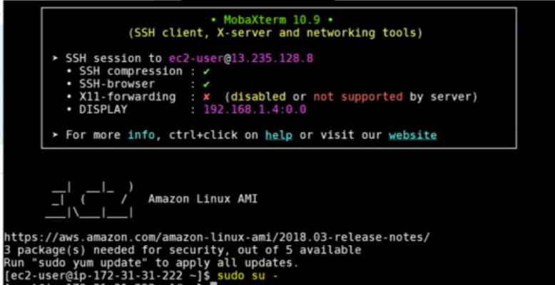

remove already predefined Java from the Jenkins server and install latest version of Java

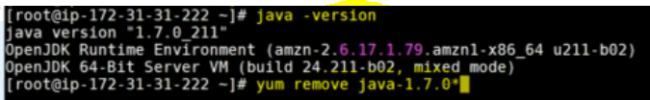

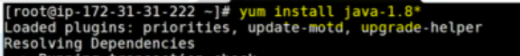

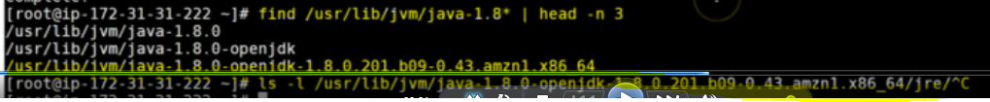

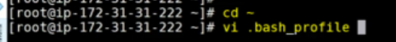**going to home directory and add jdk path in the .bash_profile file.**

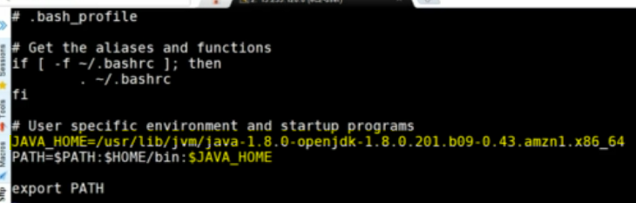

**once set up the path need to log of and login to the server then only we can able to see updated path in the server.**

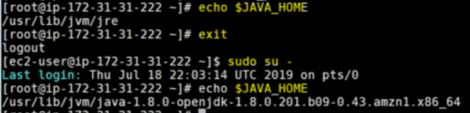

**to install the Jenkins into the Linux server please use below command**



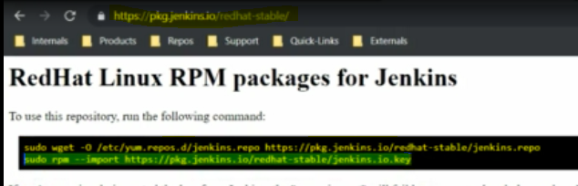



**then login for the Jenkins URL IPaddress:8080**

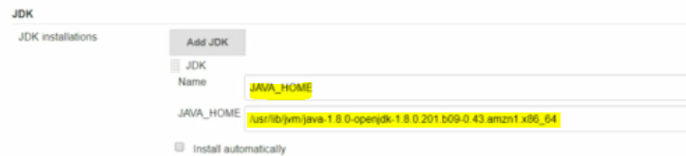

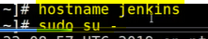**Just changed the host name as a Jenkins**

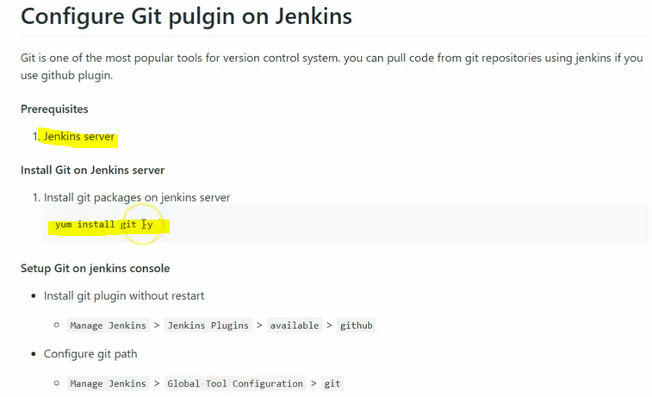

** Installing the git in the Jenkins server and install the github plug-in and configure in the global tool and configurations.**

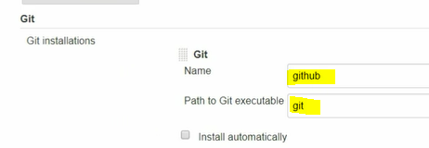

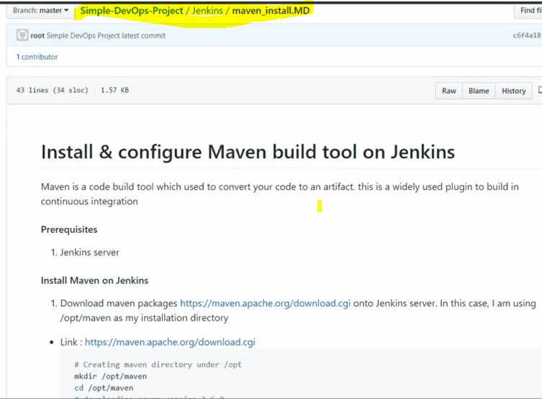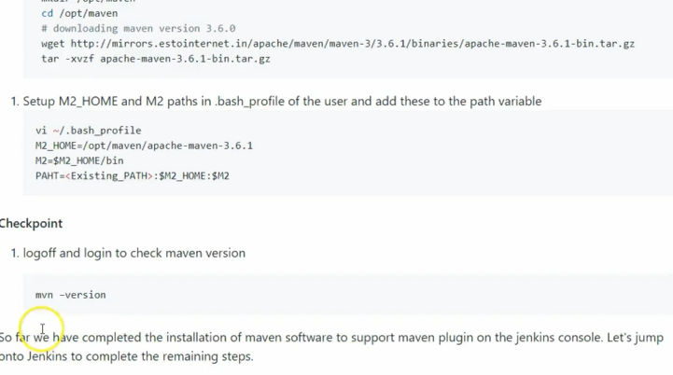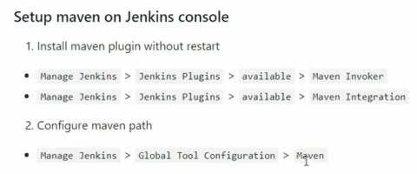

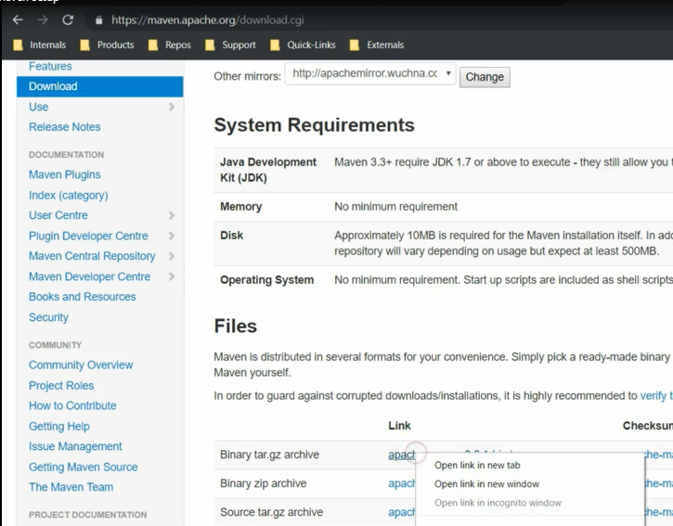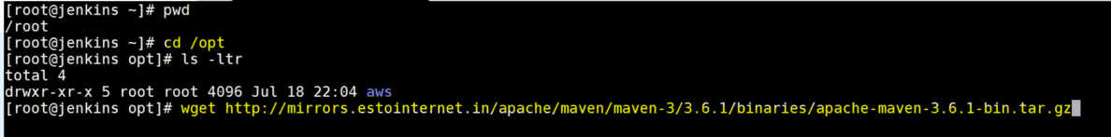

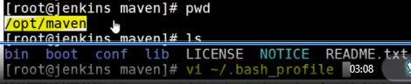

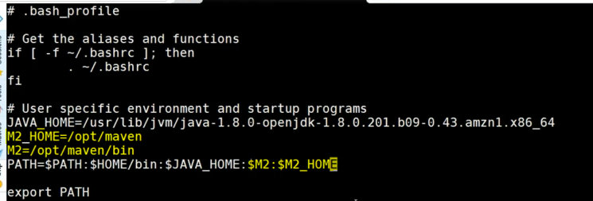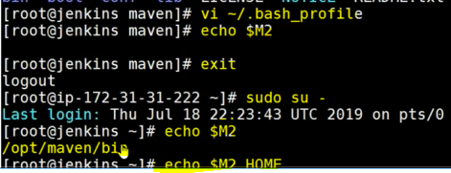



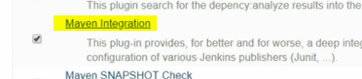



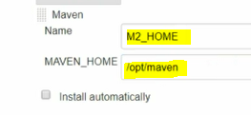

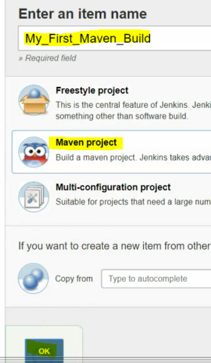

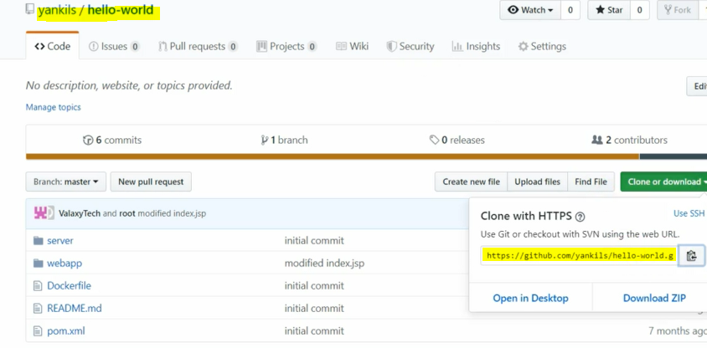

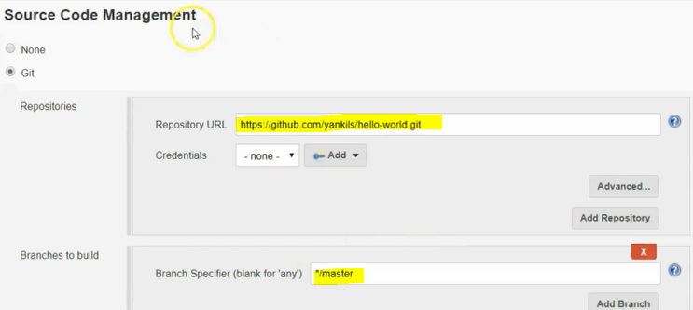

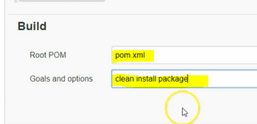**save and run the job**

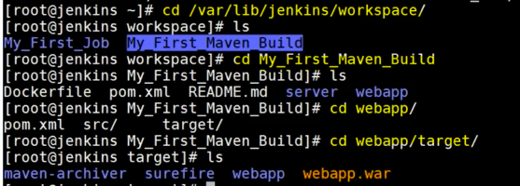



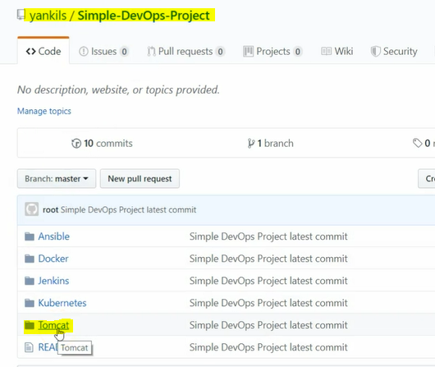

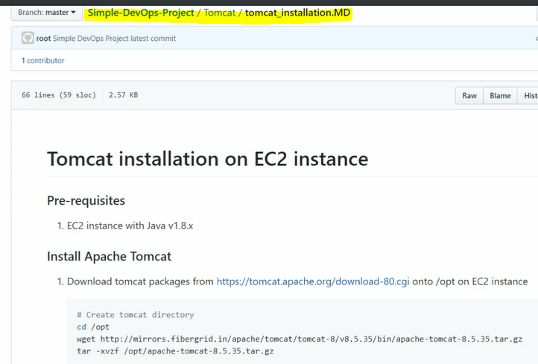

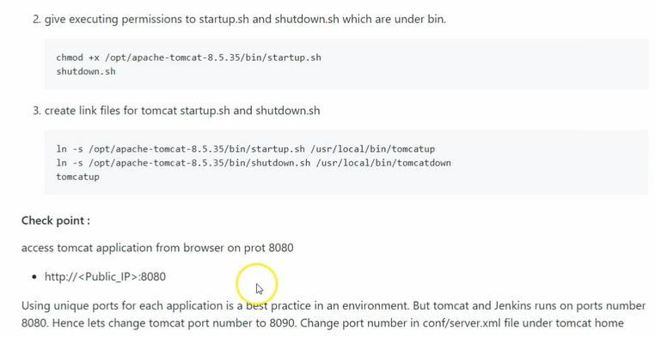

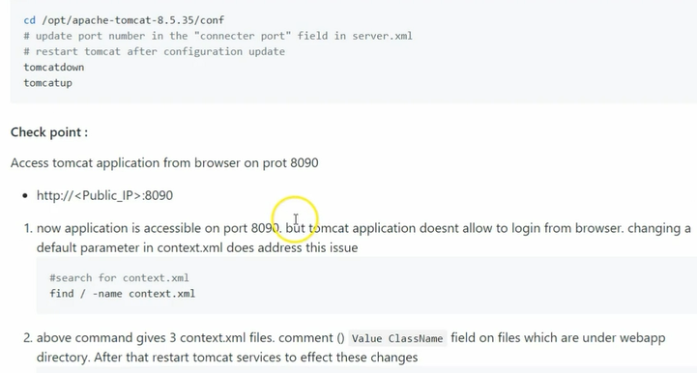

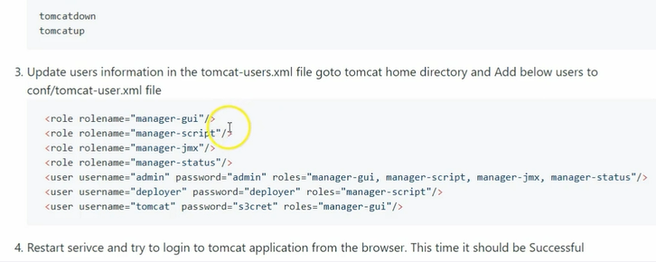

**login for the Tomcat server using below:**

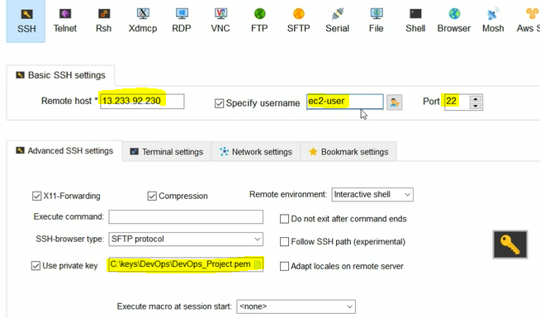

**copy the link and install tomcat**

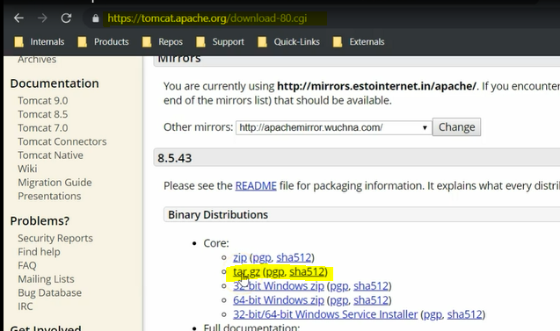

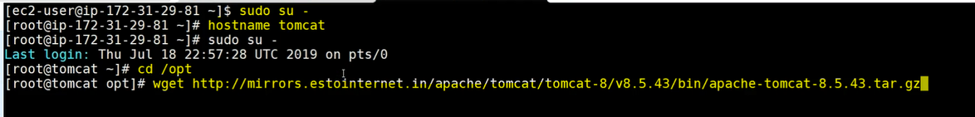

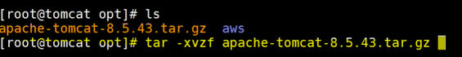

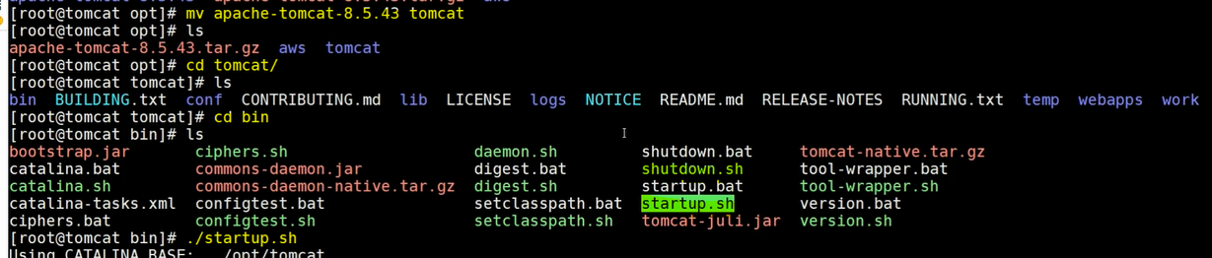

**after started the server need to check URL ipaddress:8080 tomcat working or not**

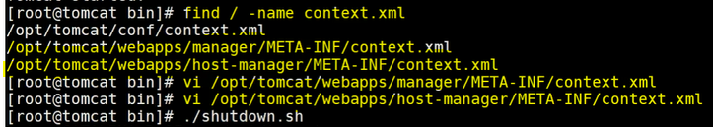

**commenting for the both above files using ip based login users in the tomcat managers.**



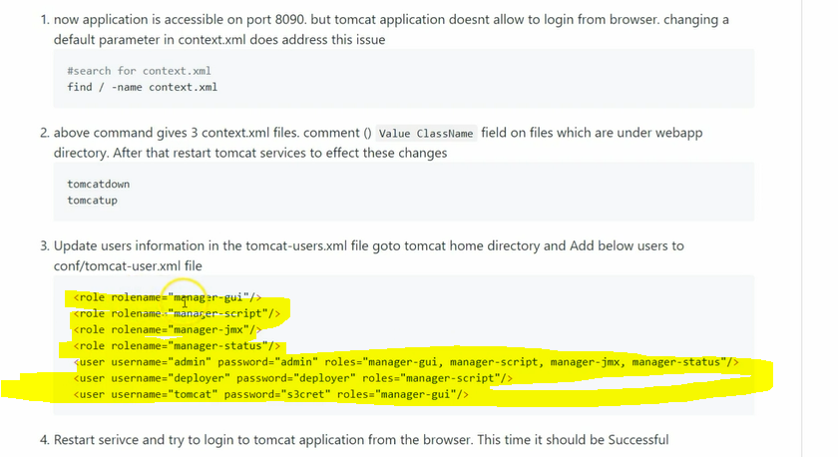

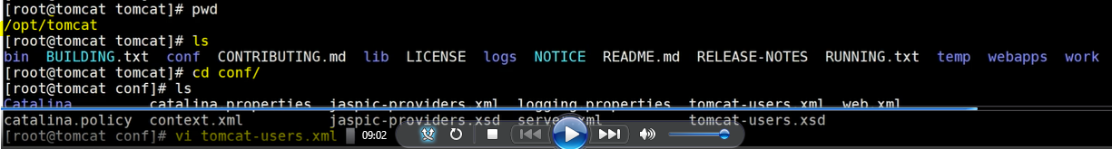

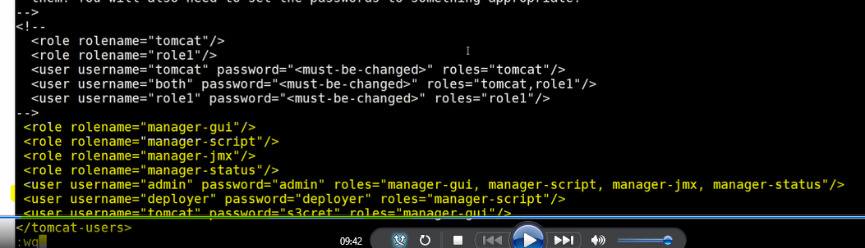

**after update the user credentials in the tomcat_user.xml file need to restart the servers. then try to login for the tomcat server**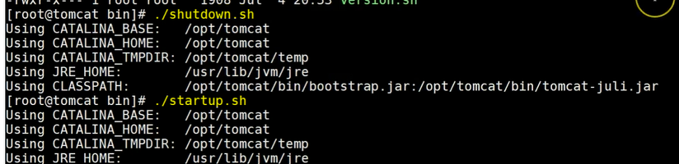

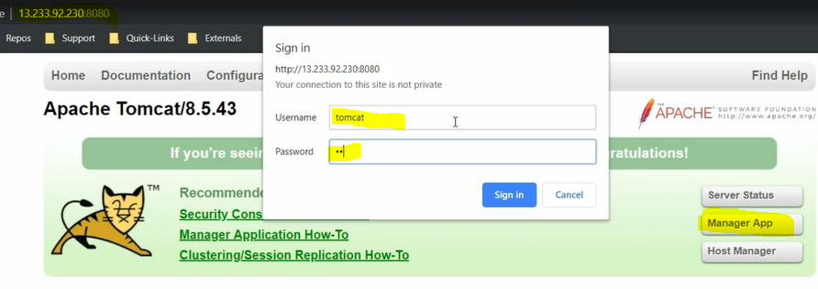

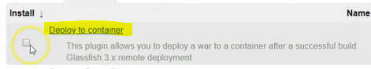

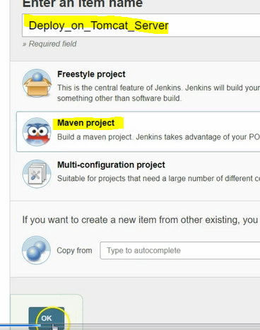

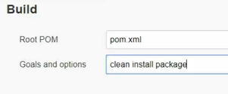





**add above user as a tomcat deployer user and tomcat URL as below like server ip address and port number.**

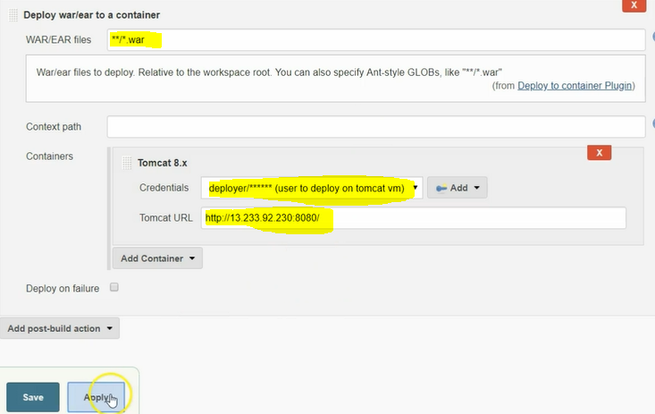

**then build it for the deployment check in the server if the files are successfully deployed or not.**

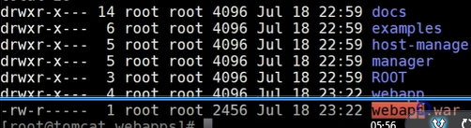

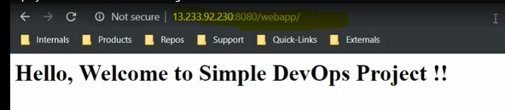**v-13**

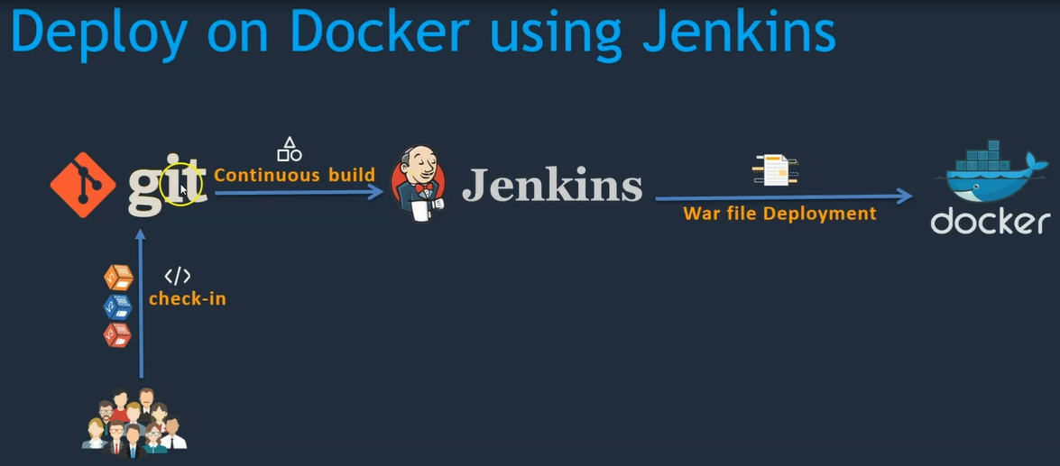

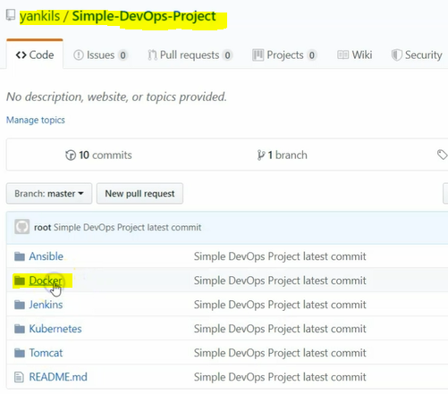

**Install docker in the ec2 machine and using below steps.**

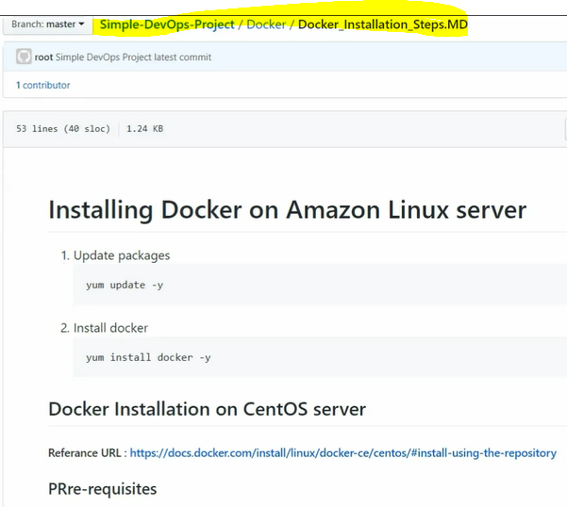

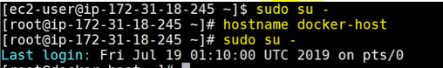



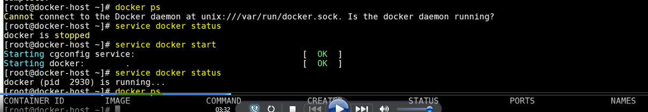

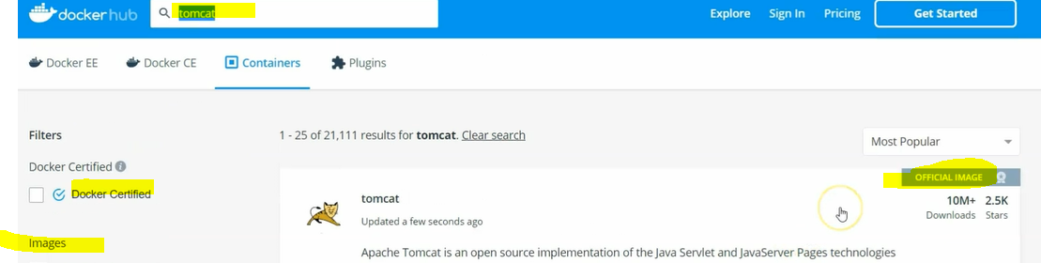

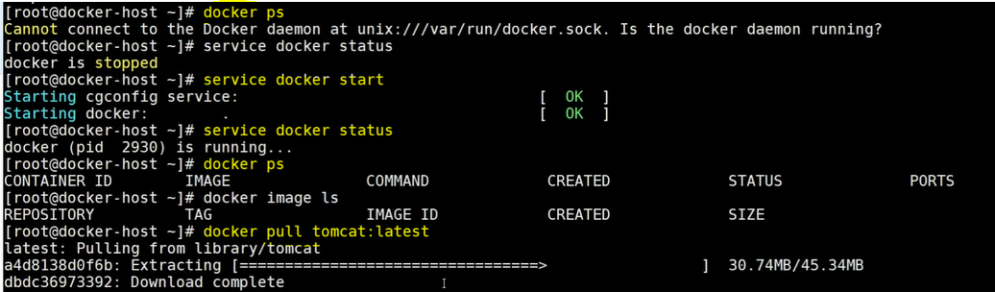

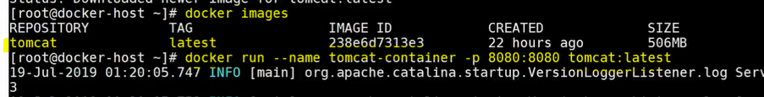

**the above command will create docker container and runs in the foreground**

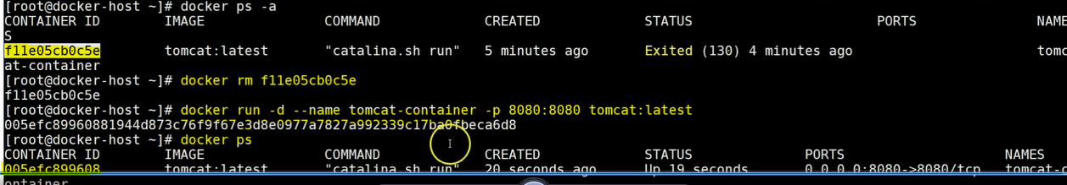**d--stands for detach mode**

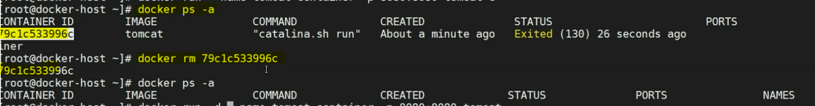



**login in to the container will use below command and then copy the file in to webapp from webapp.dist folder then refresh browser and check it working or not.**

**v-15**

**it will login into docker container within folder /bin/bash copy the structure webapps.dist/ to webapp folder**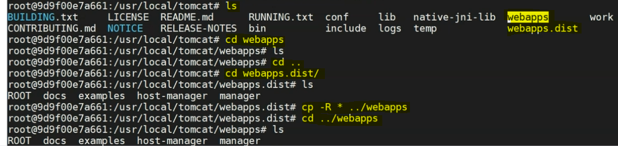

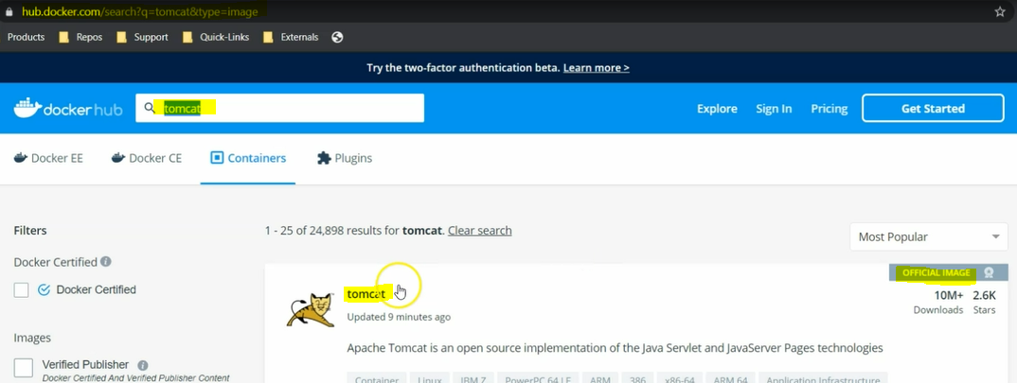

**full the old and stabled docker image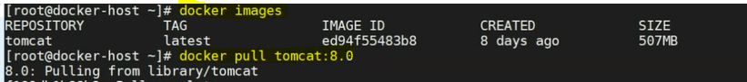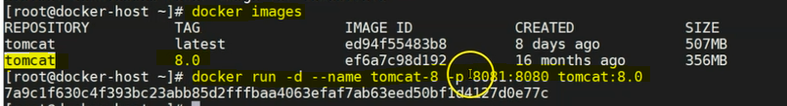to check containers are up and running**

**Create Docker user in the docker server**

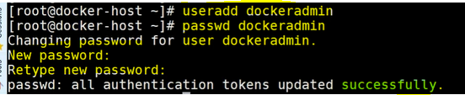

**user added into groups**

**adding DOCKERADMIN user in the Jenkins configurations.**

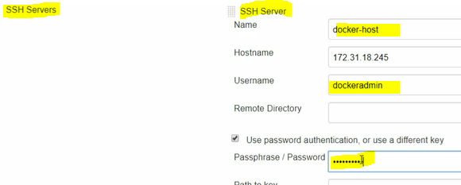

**to enable password authentication on the serversshd_config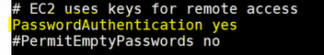reload service**

**service sshd reload====run the command in the docker server**

**Create new Jenkins job as like below and clone the previous job configuration using below option.**

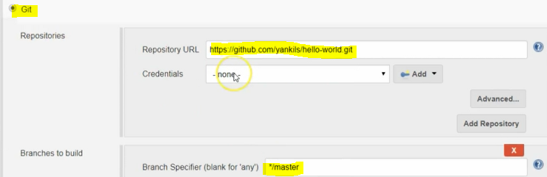

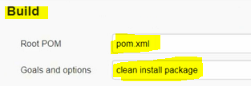

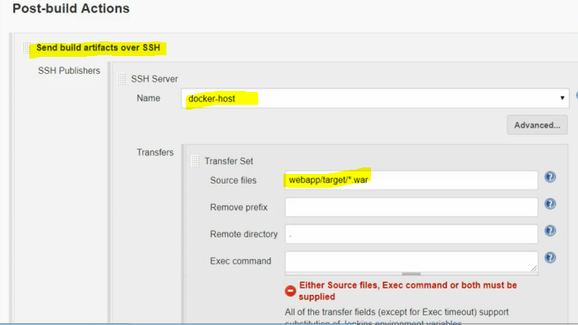

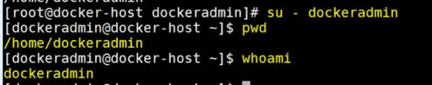**lets build the job**

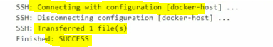**deployment has done**

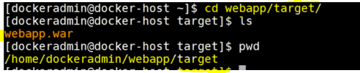

**let's create docker file**

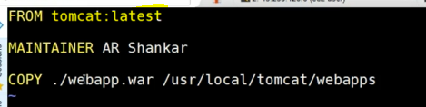

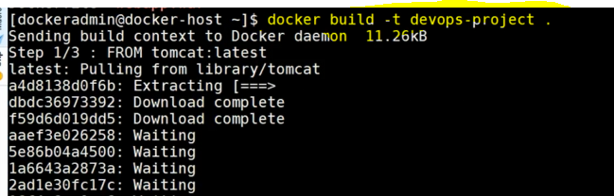

**building the docker image and from docker image to docker container (devops-project is tag for the container)**



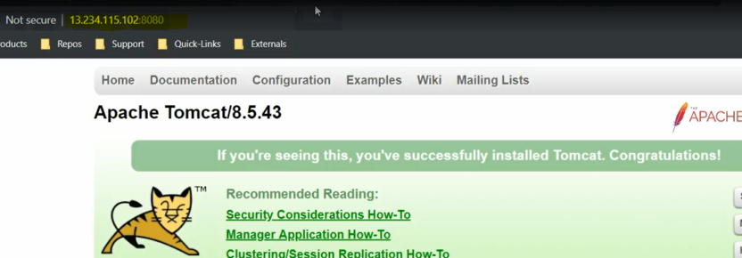

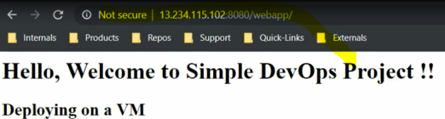

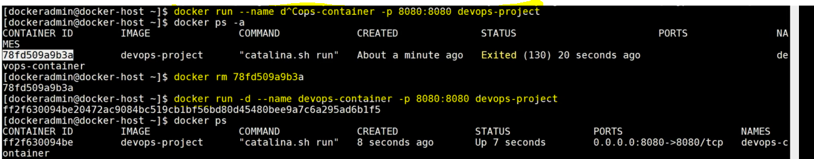

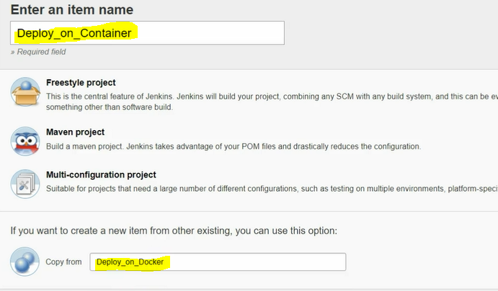

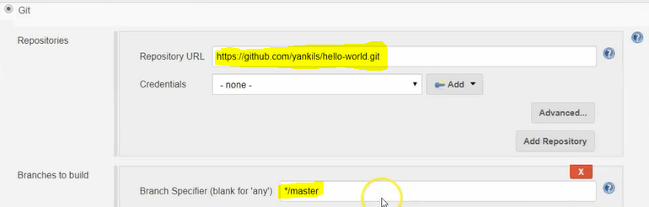

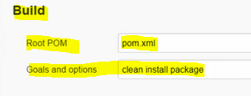

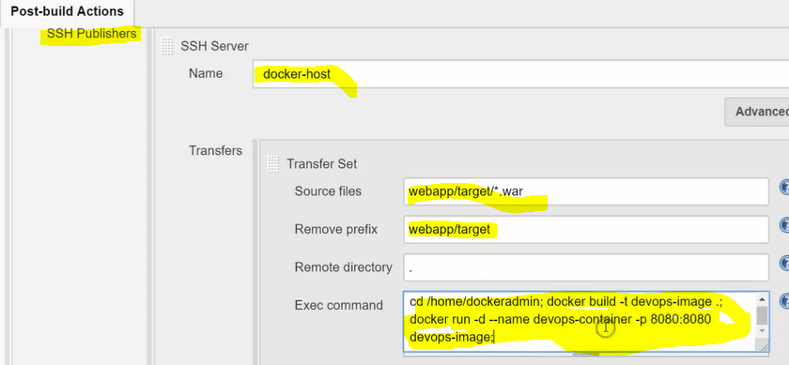**save and run it before going to run remove the war file and docker images.**

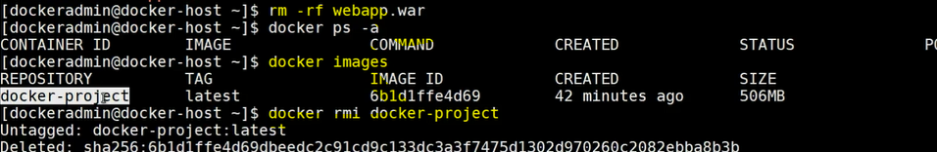

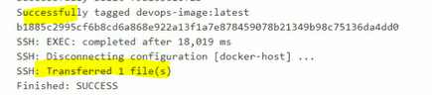**access the browser as well**

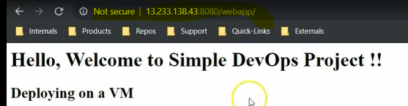

**by using Jenkins we can redeploy the same code in the tomcat server the job won't succeeded because of same file will be available to over the those problems we are going to use Ansible for the deployment.**

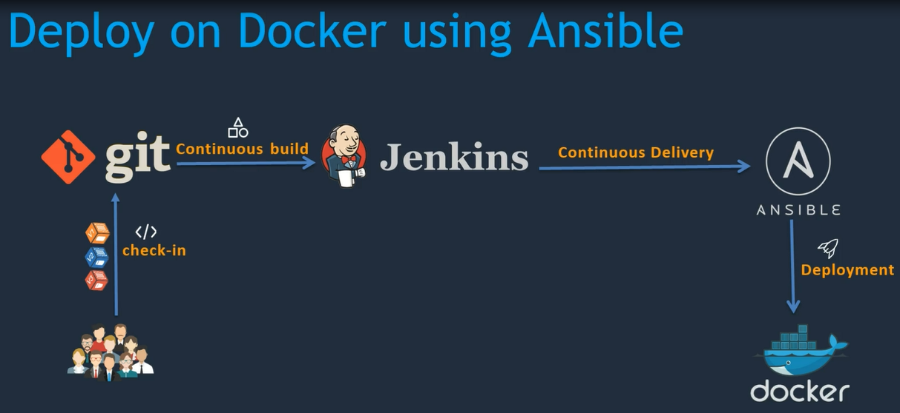



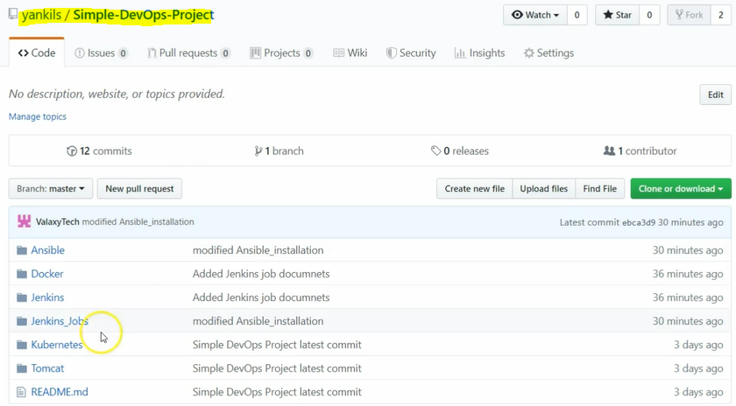

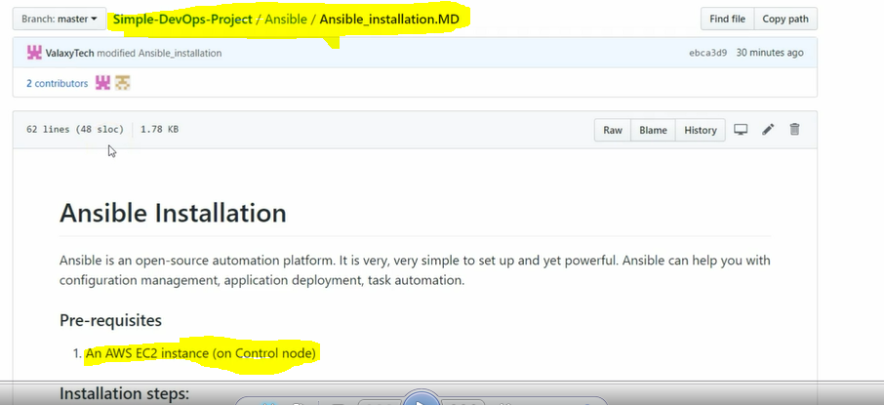

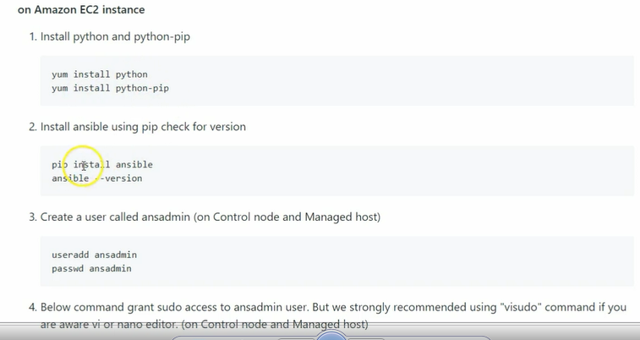

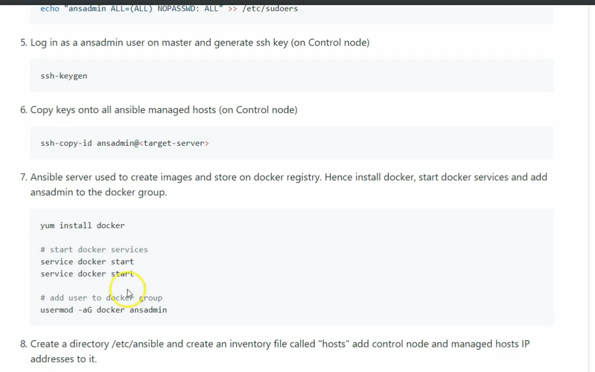

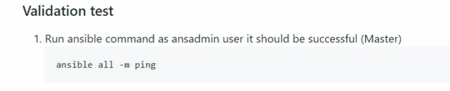

**for the Ansible server need to create new ec2 instance and install the ansible.**

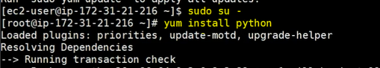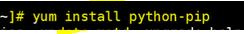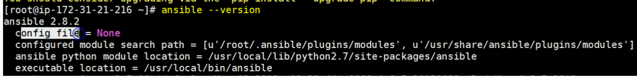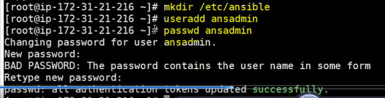

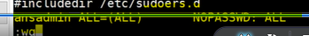**GIVING PERMISSIONS FOR THE ANSADMIN USER**

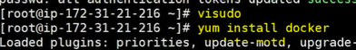

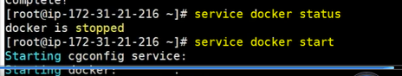

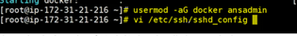

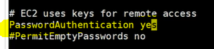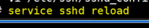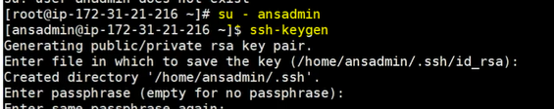

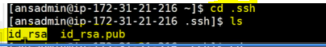**cd .. exit**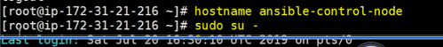

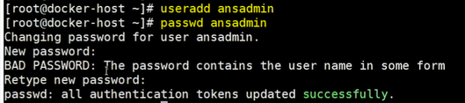

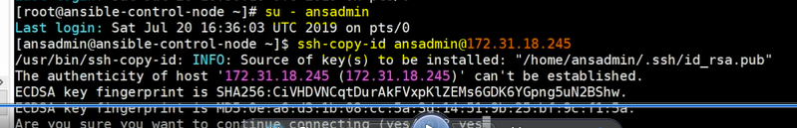

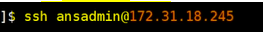**loginin to ansible control node to ansible node**

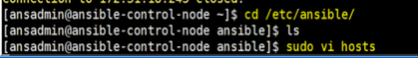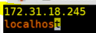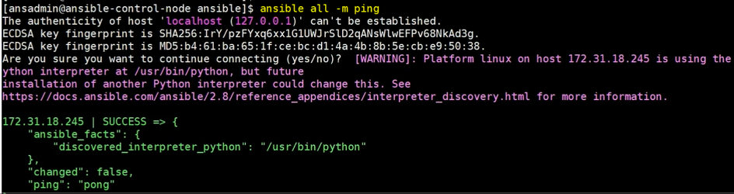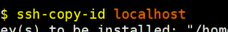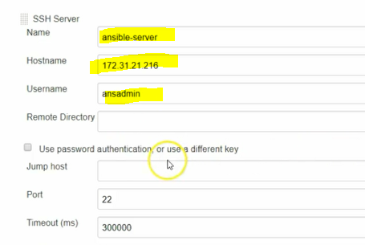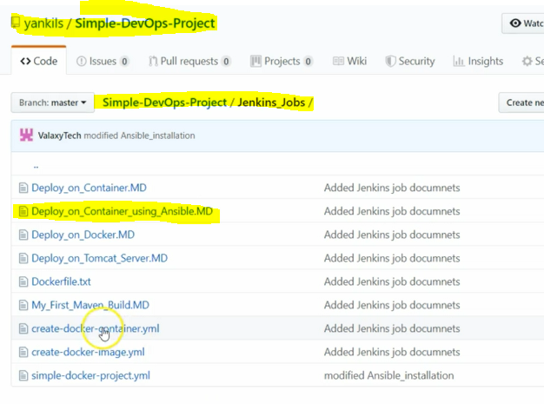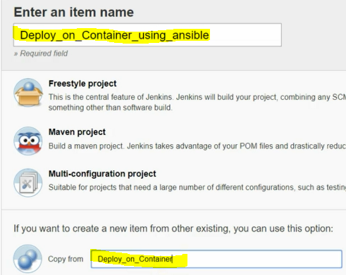

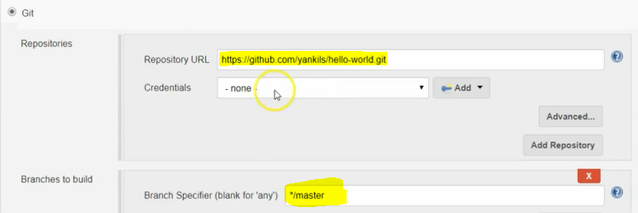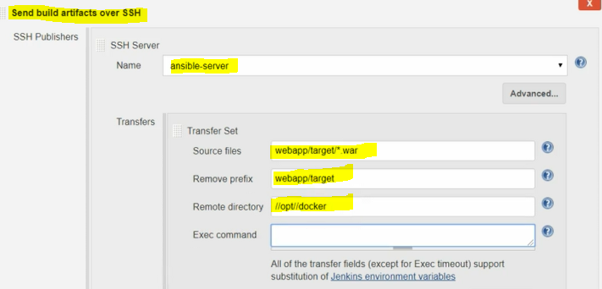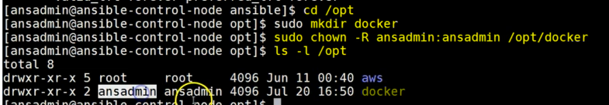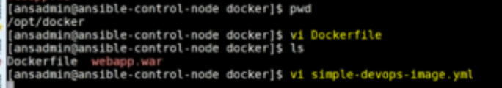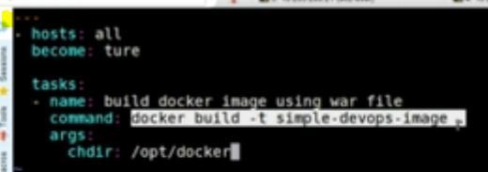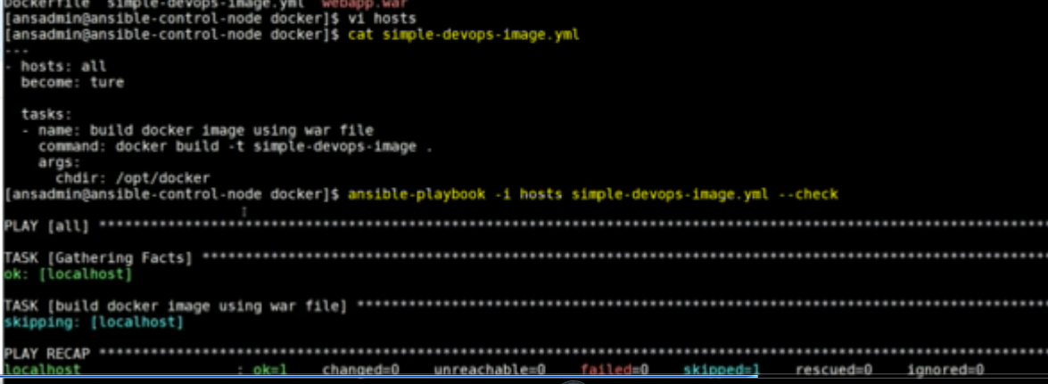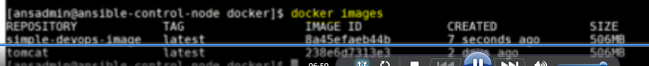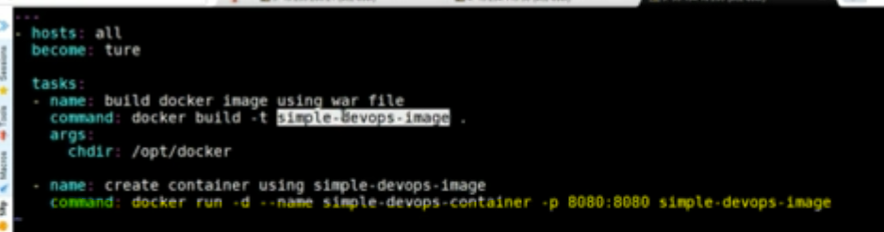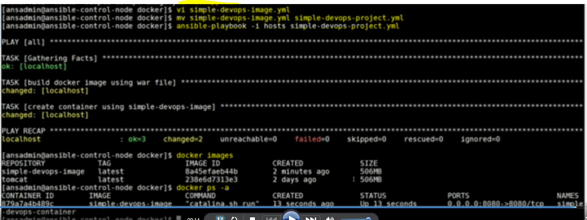

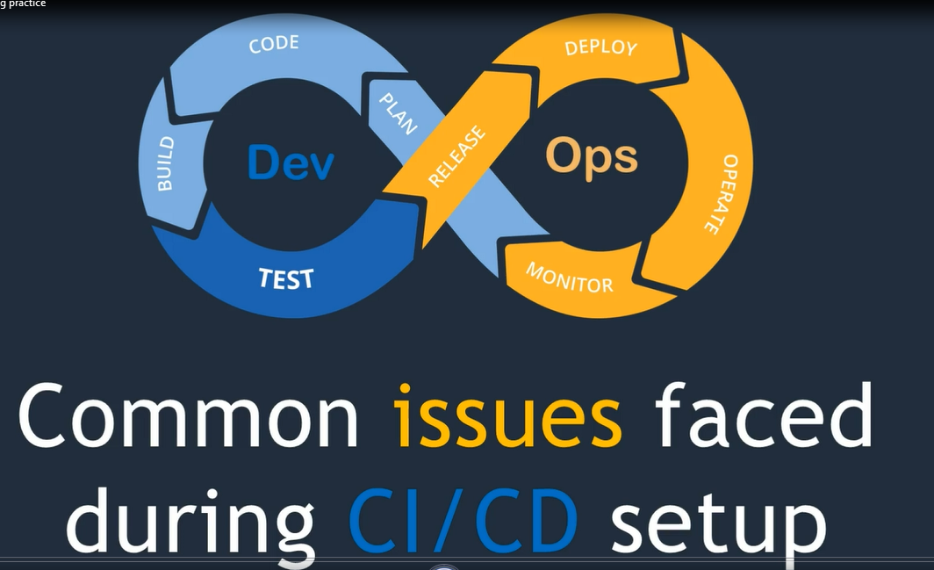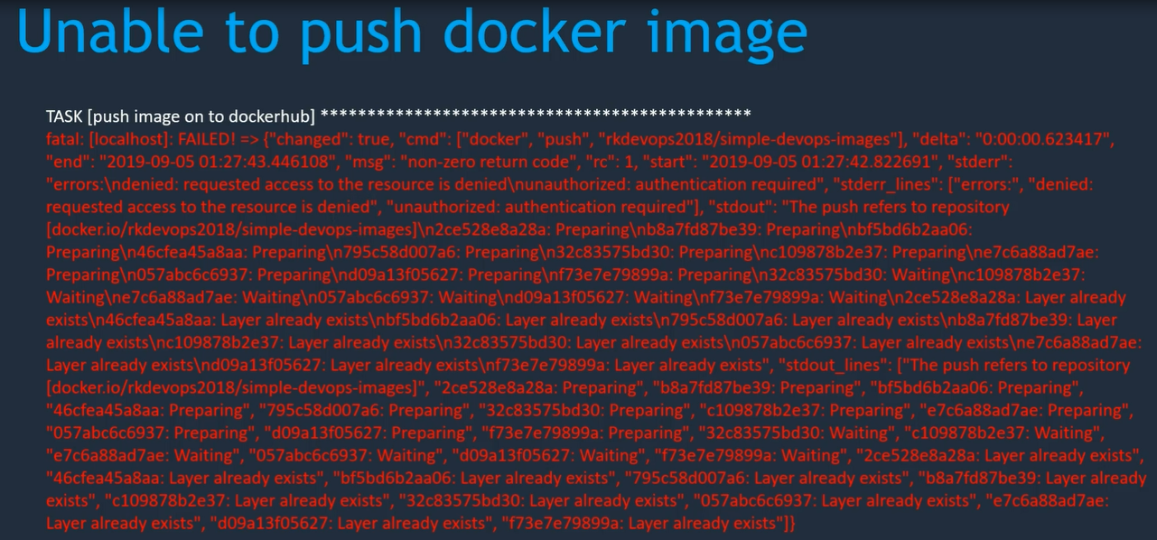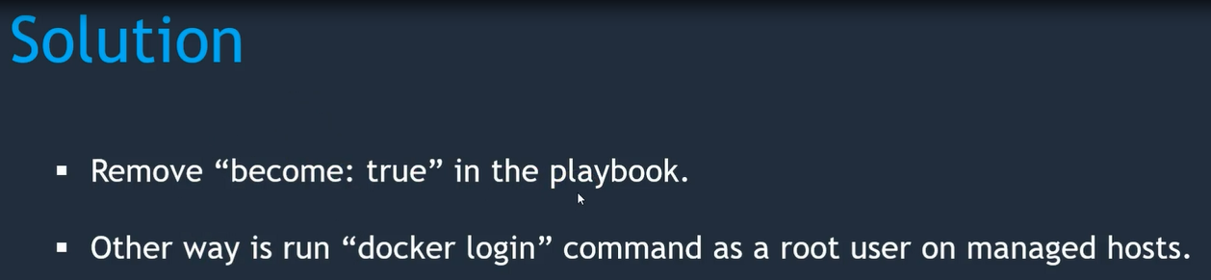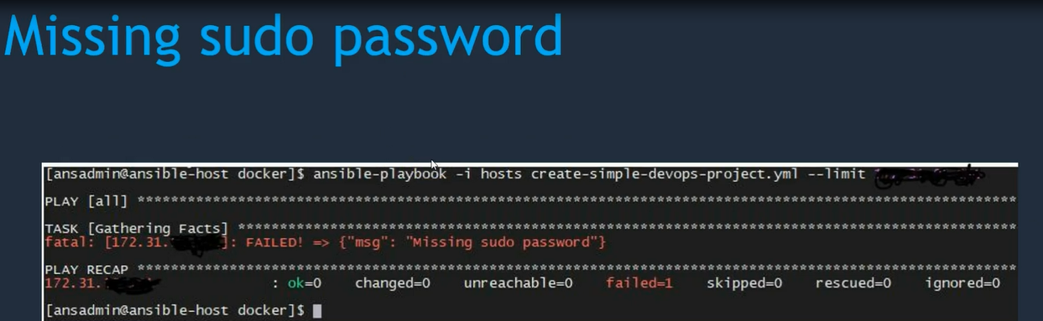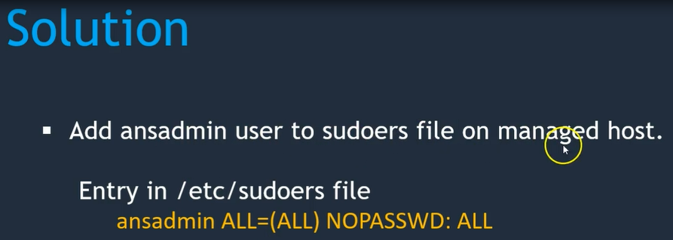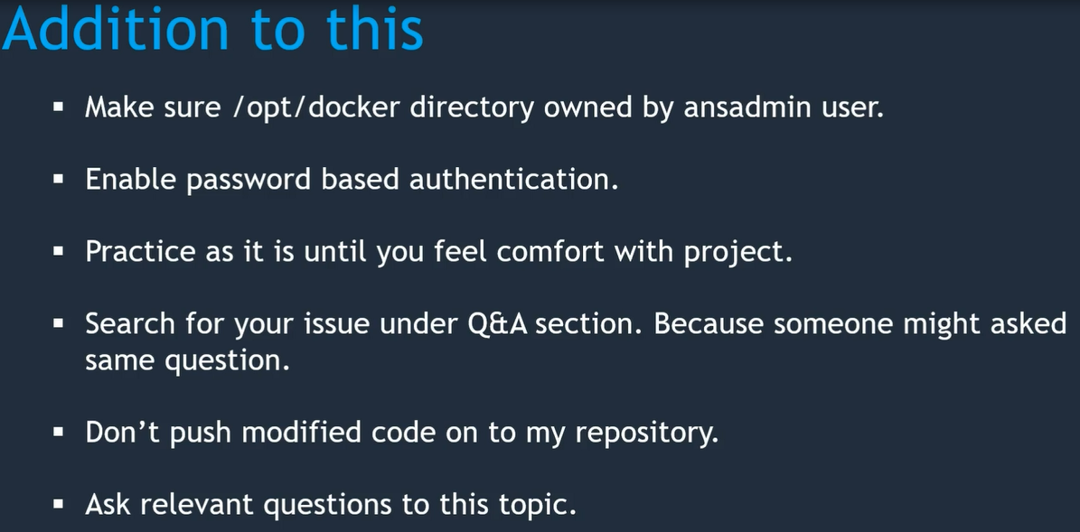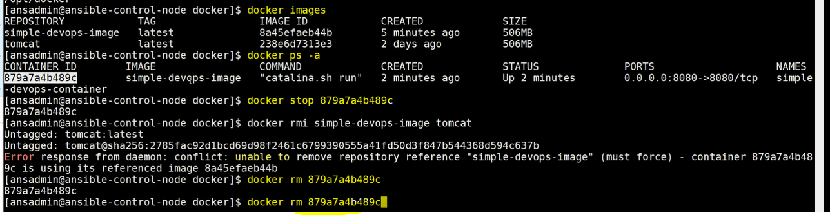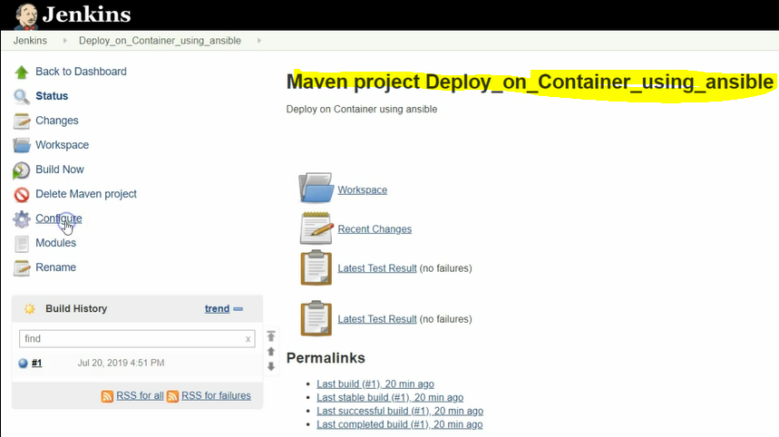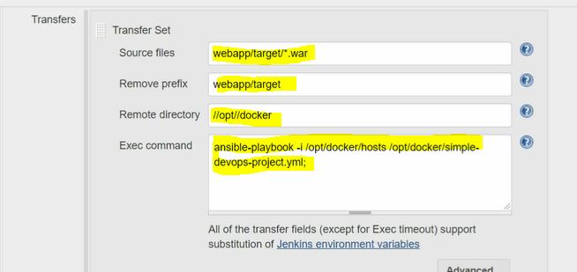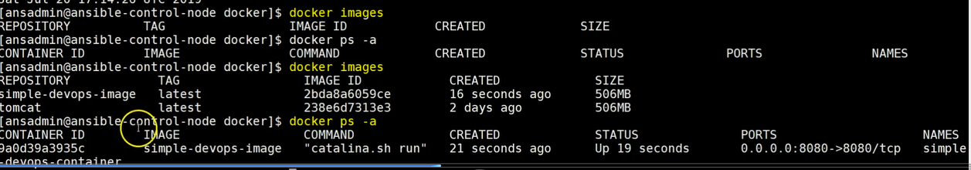

**The war file will be copied into ansible server and as well as will bring up images and containers also for the final deployment.** 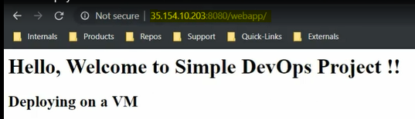

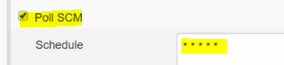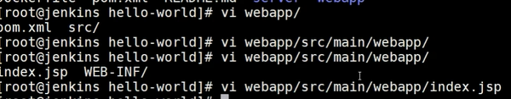**change the contain for the testing purpose.**

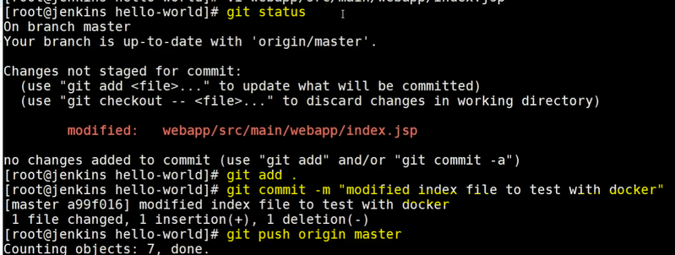

**Once changes are pushed into central repository the poll SCM will be trigger the job automatically and failed with unstable error. why because already the containers are up & running. to overcome this issue need to stop the container before start the playbooks then start the fresh containers again.** 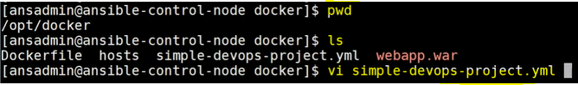

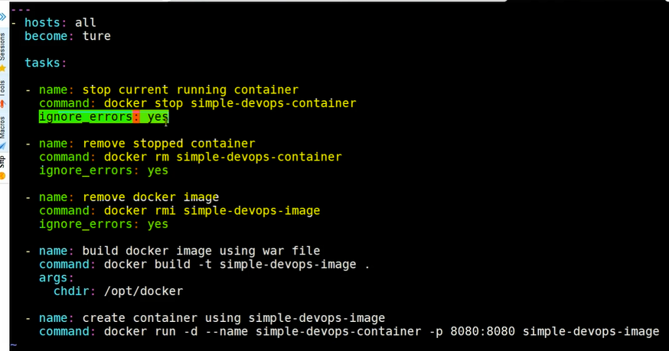

**The above playbook will initially stop the already running containers and remove the containers and images--->ignore_errors:yes means if already the container stopped or not available in the server it will be ignored and job won't be failed. and build the Jenkins job now for the new changes in the UI WEB.** 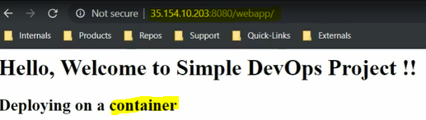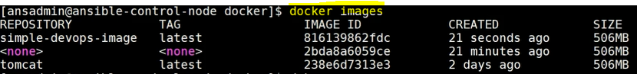

**Ansible:**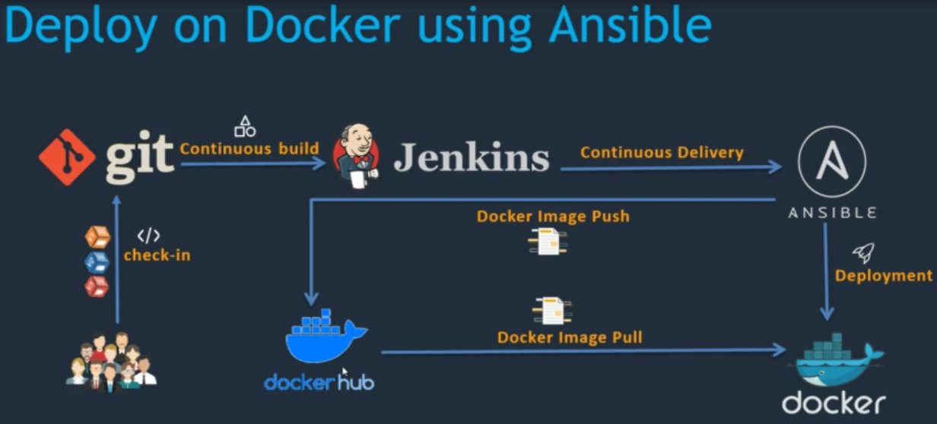

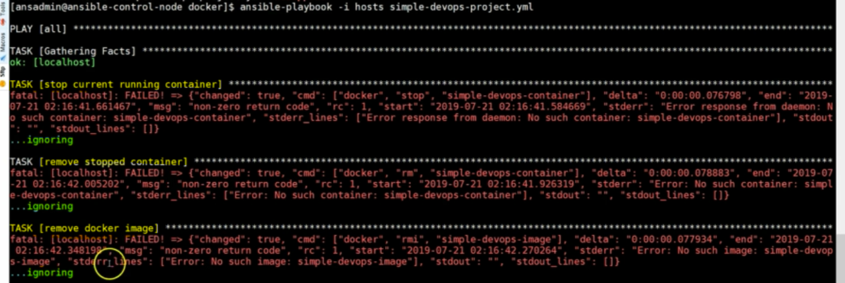

**login to dockerhub portal and push the images into dockerhub.**

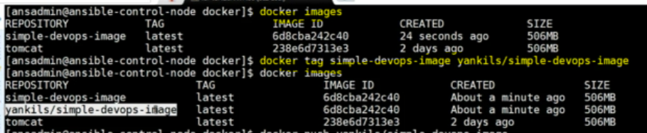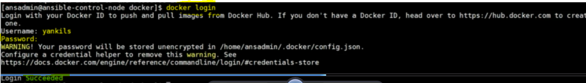

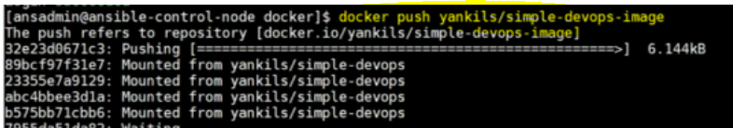

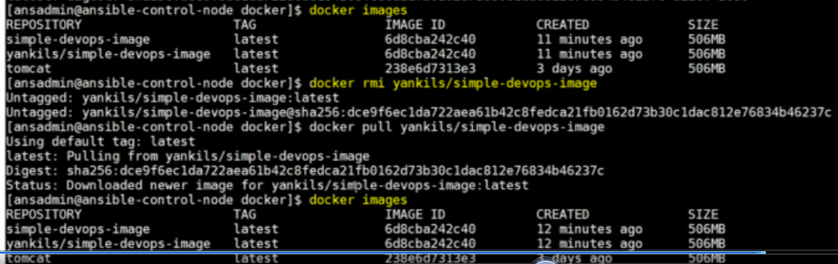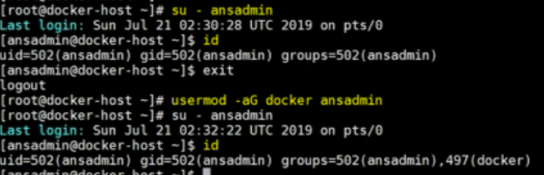

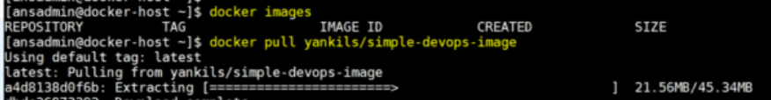

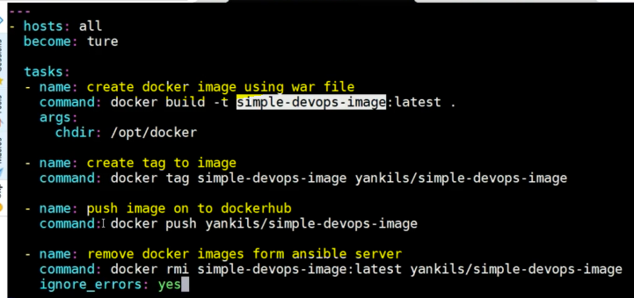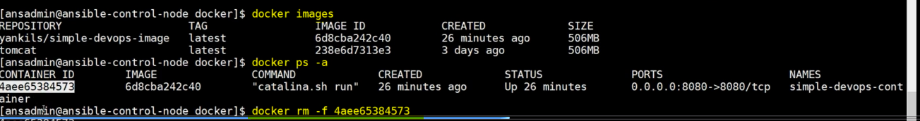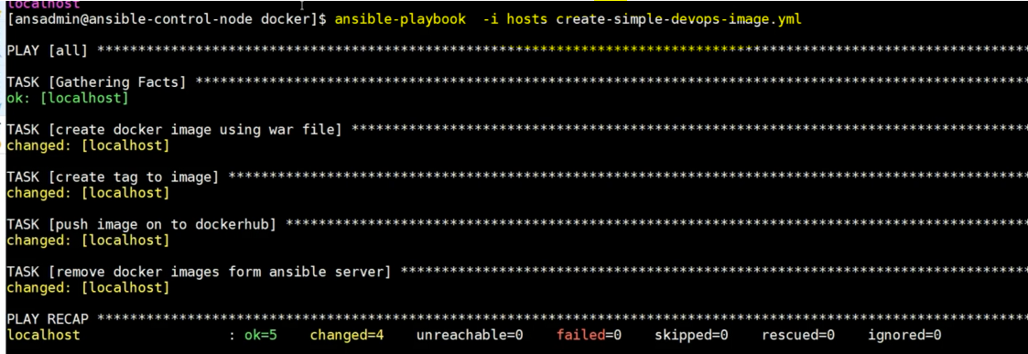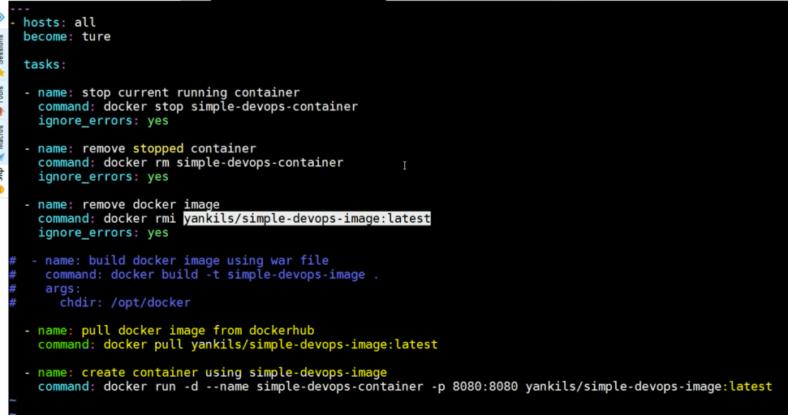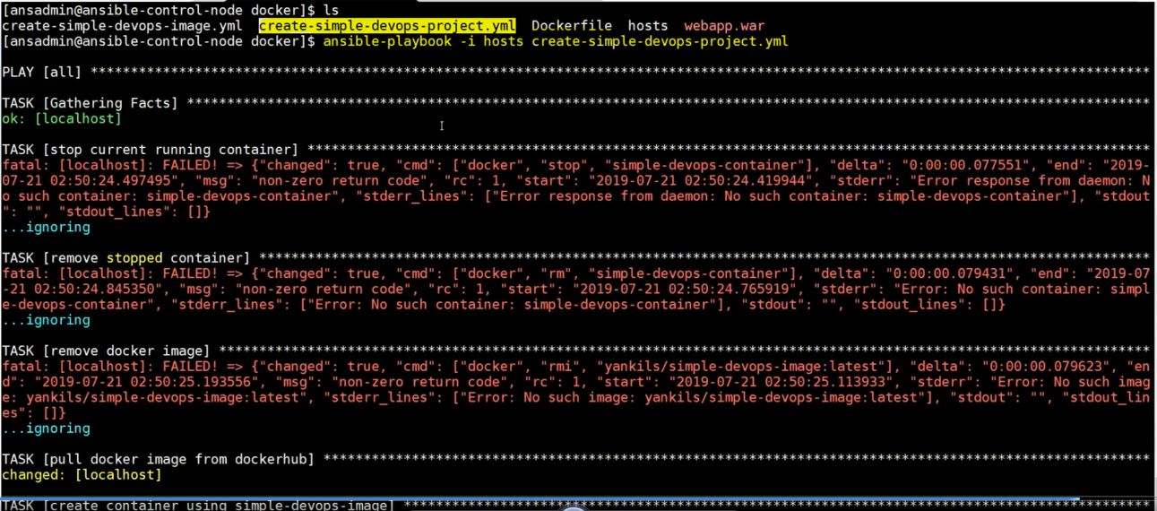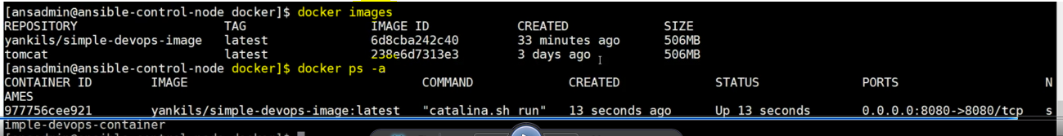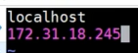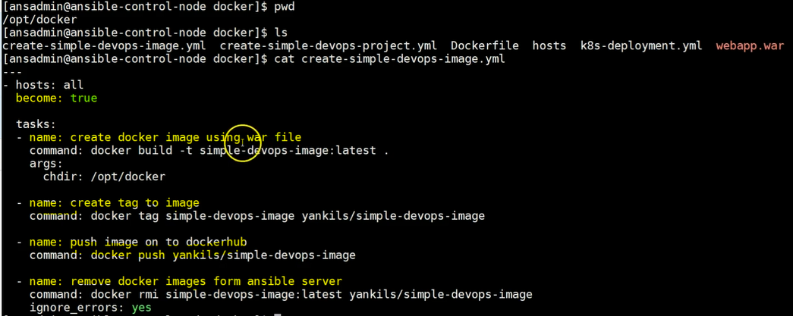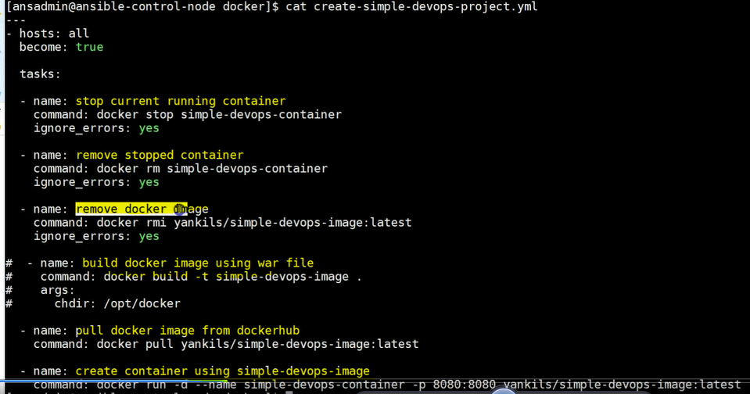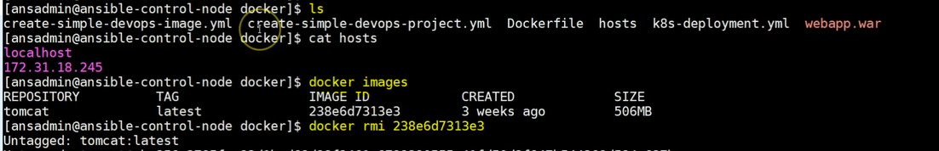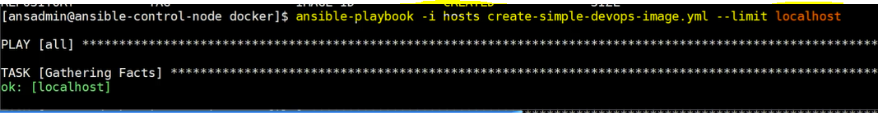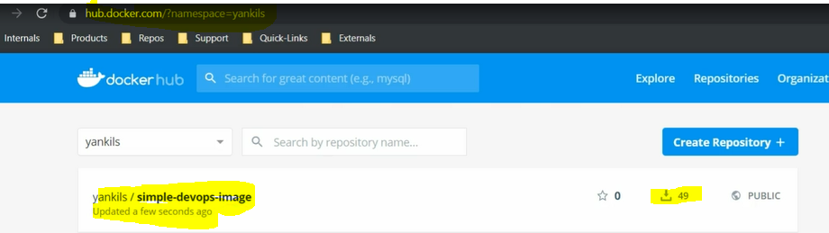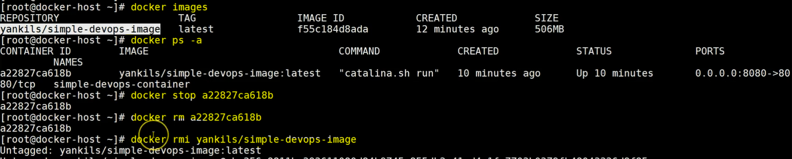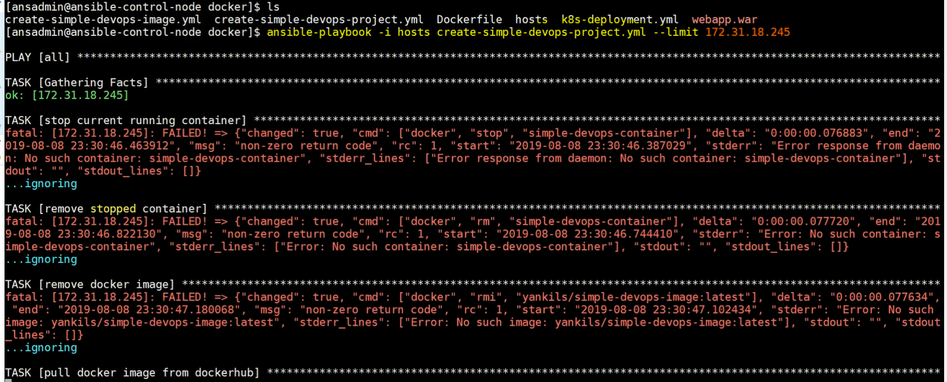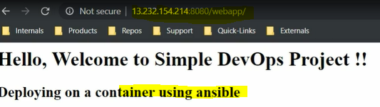

**By Using Jenkins Job we are going to execute the entire ansible CI/CD**

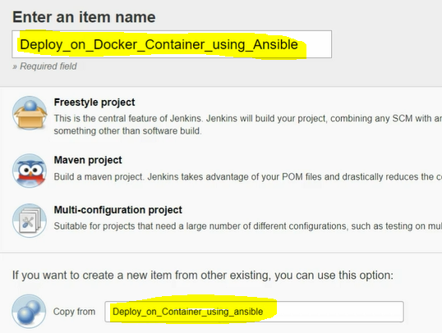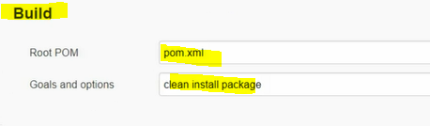

**now we are running two playbooks with different systems.**

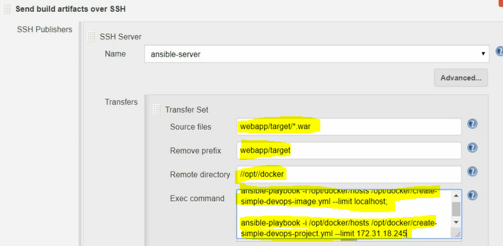

**save then the job will automatically start using POLL SCM intravel.**

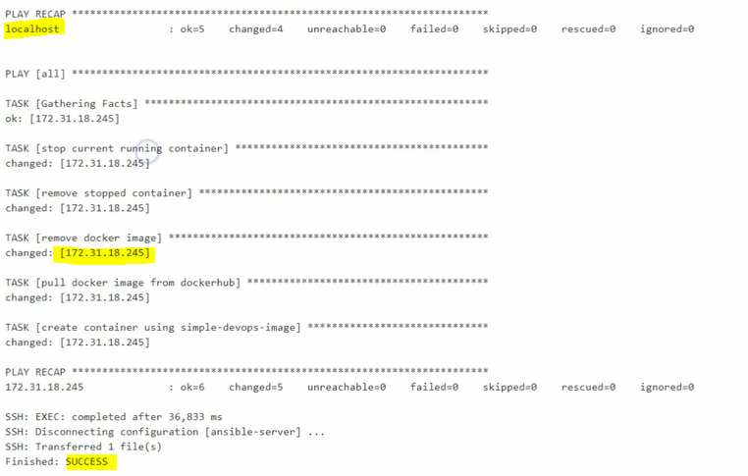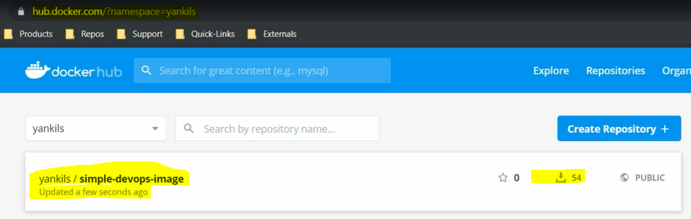

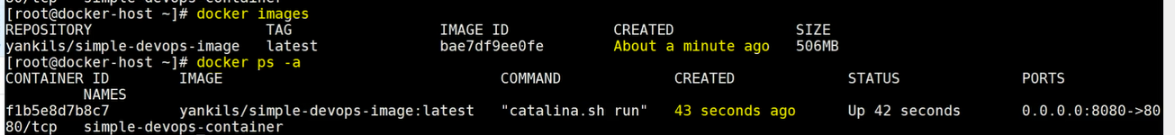

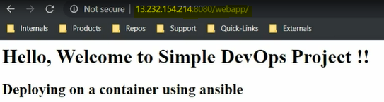

**if we update index.jsp file the Jenkins job will be started automatically and update the docker hub as well tomcat webpage as well..**

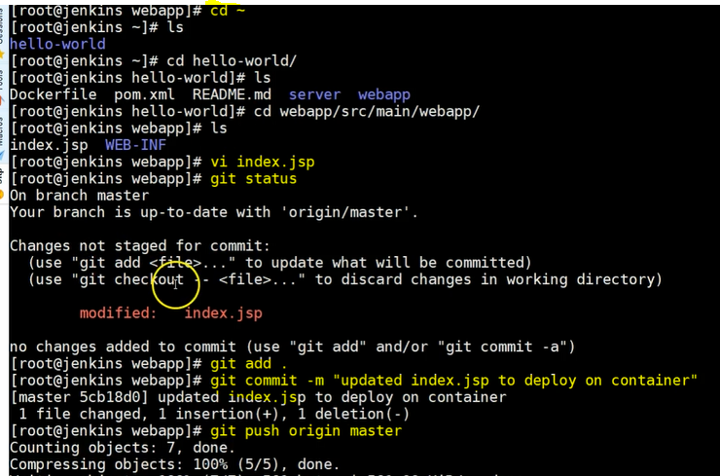

**Kubernetes: To maintain the our containers will use Kubernetes, Kubernetes is container management service, if it find any faulty containers it replaces with new containers or desired capacity of containers are not available it creates new one.**

**Due to some problems our container is not working we need to create manually or we should need to rerun our Jenkins job. Jenkins job execute only there is an new build to overcome these problem kubernetes will able to take care or maintain our containers. that is Google comes up product called kubernetes.**

**Whenever node has unavailable automatically create new node will be created**

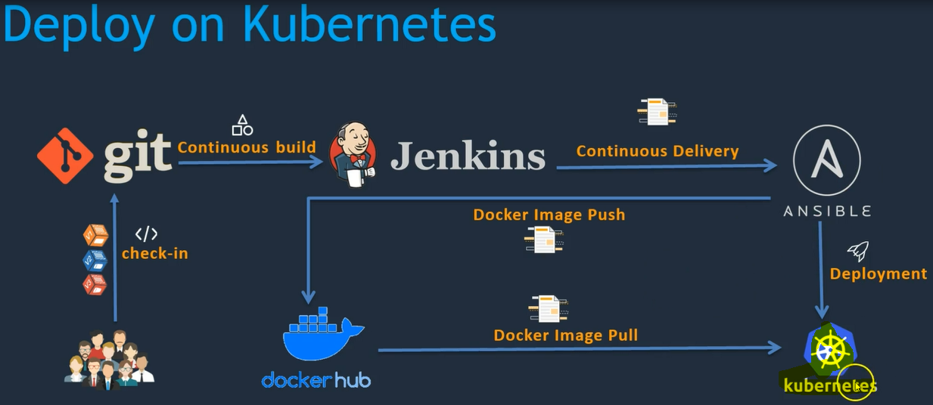 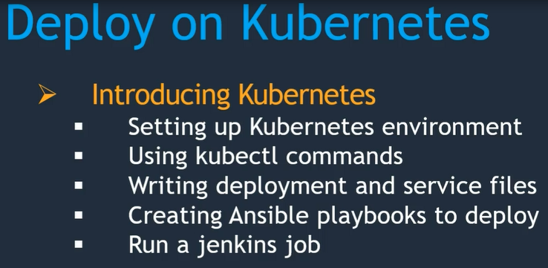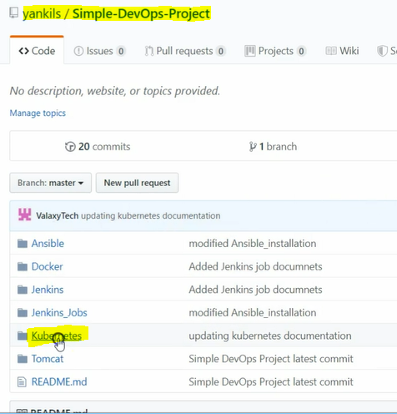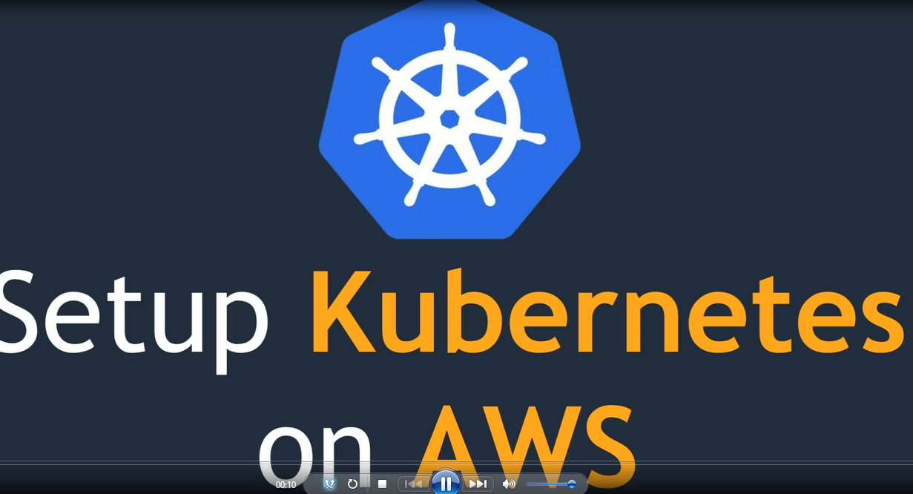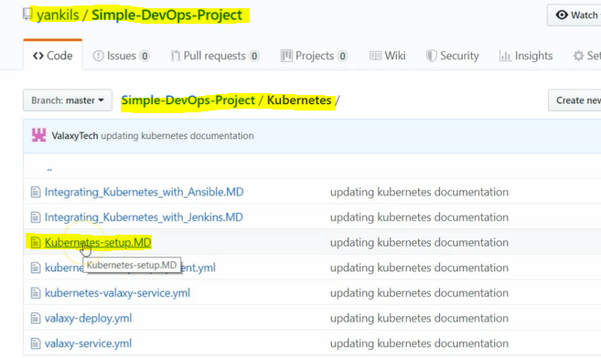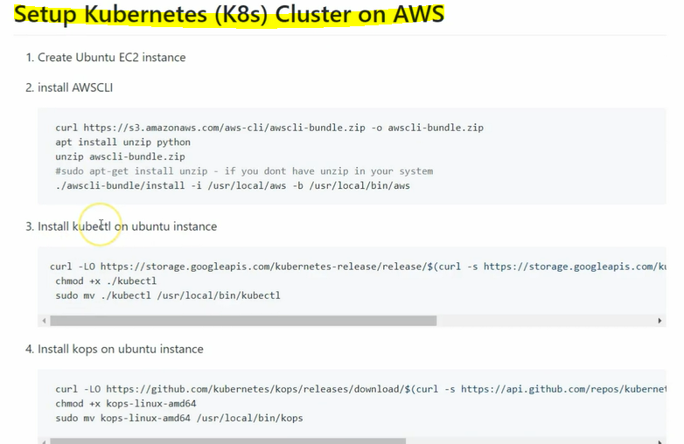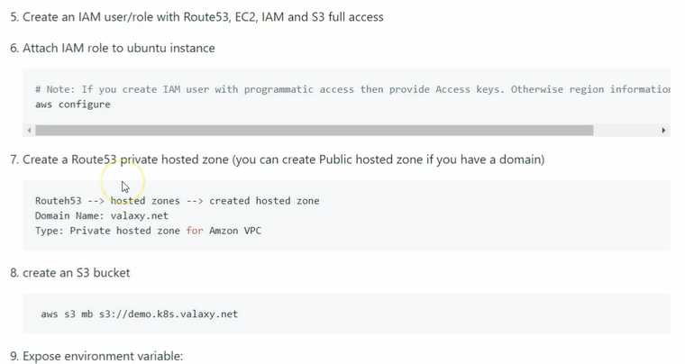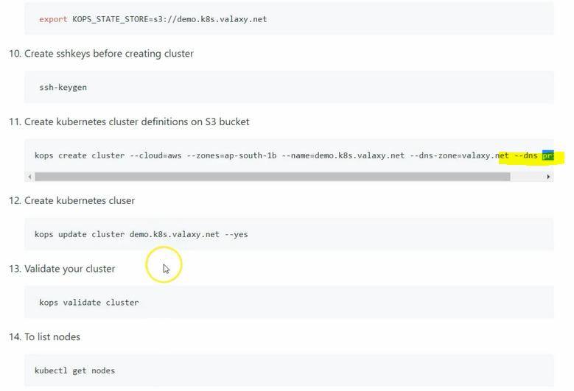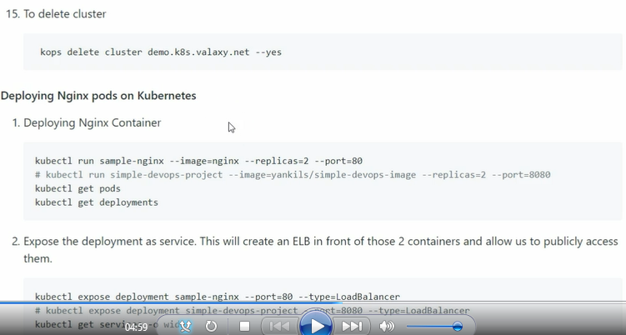

**Create ec2 instance using ubuntu server.** 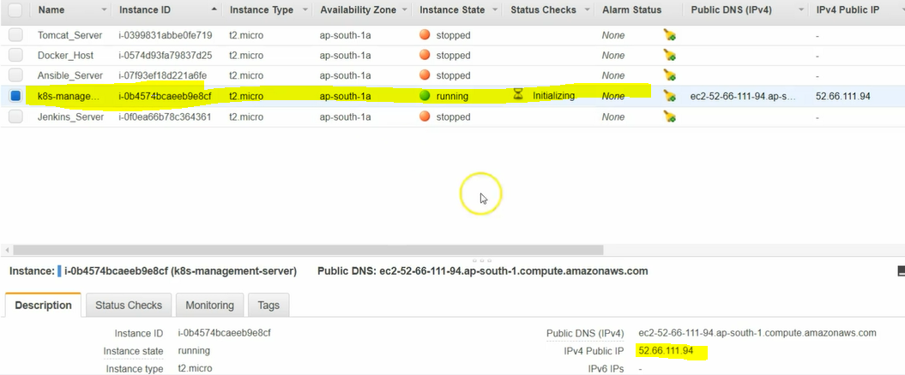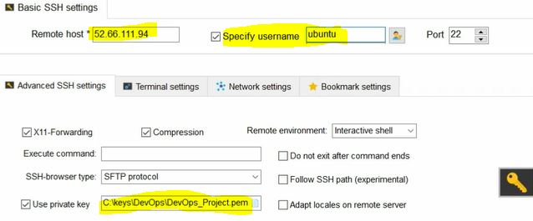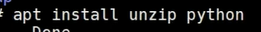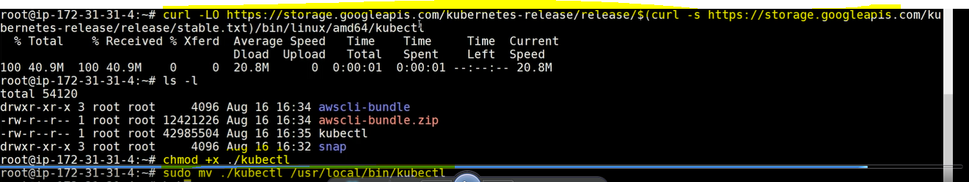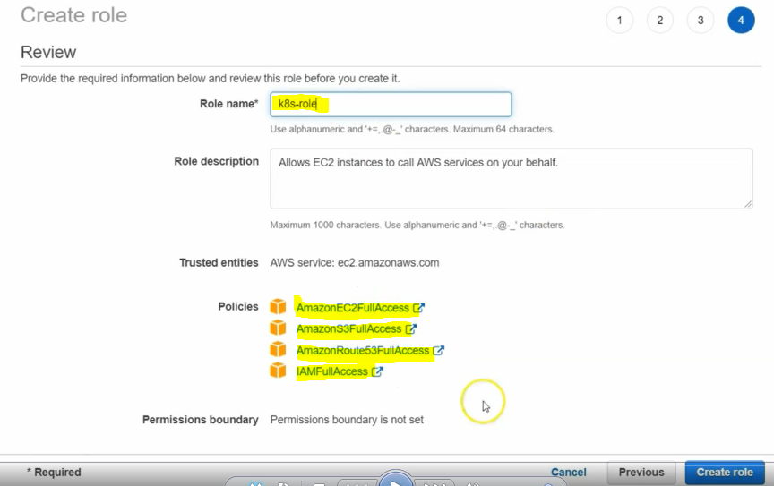

**The above role needs to attach to ec2 instances**

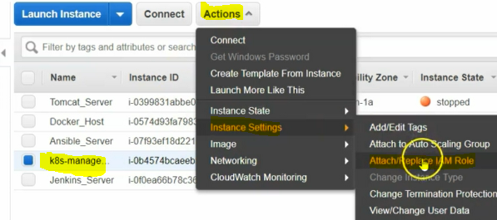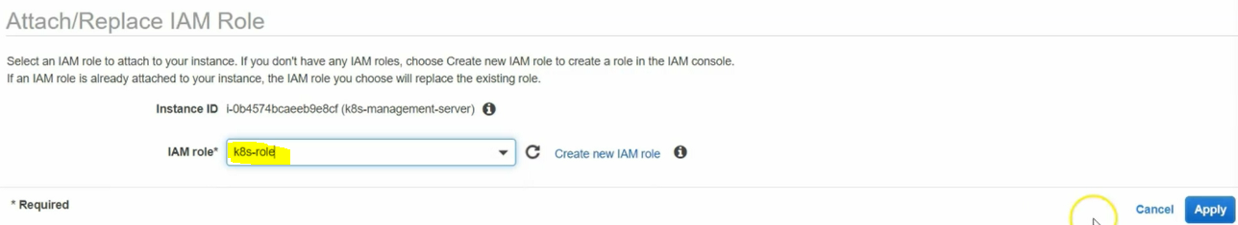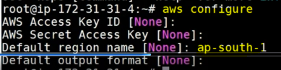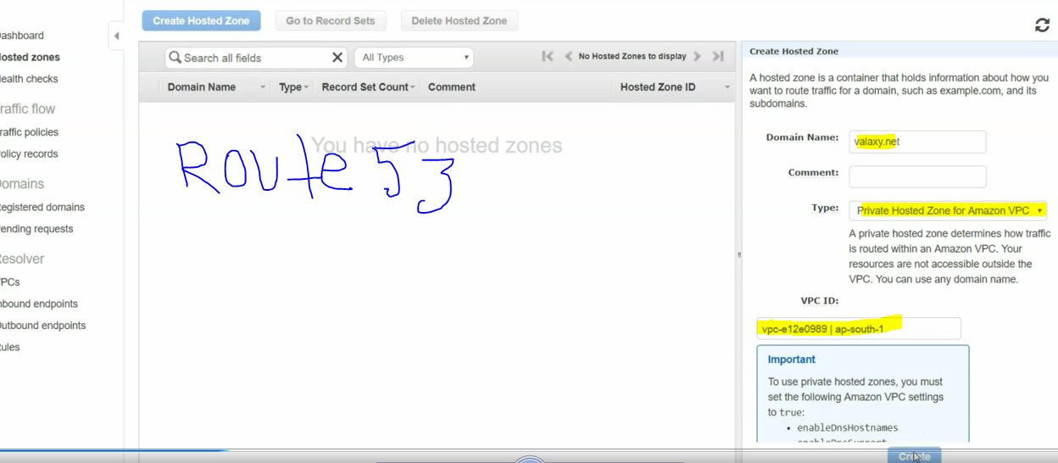

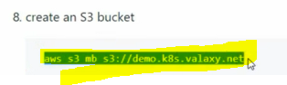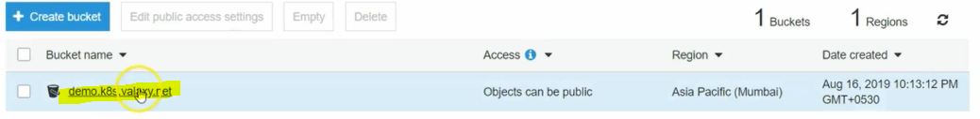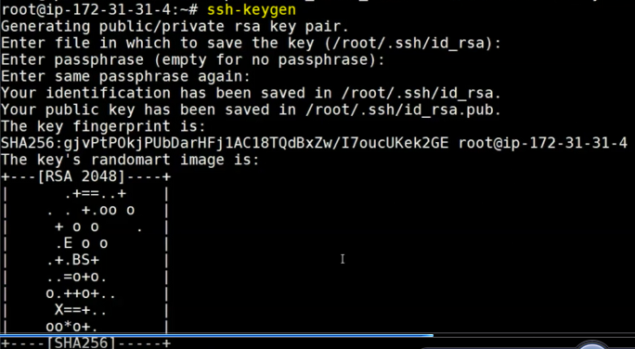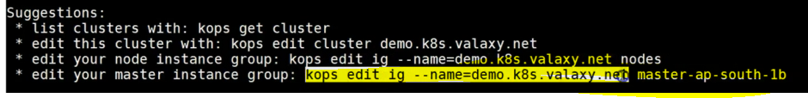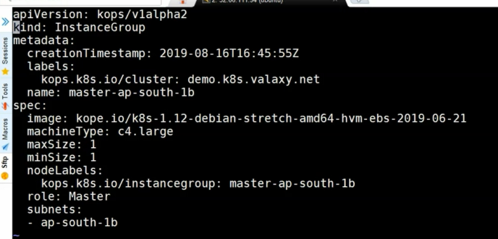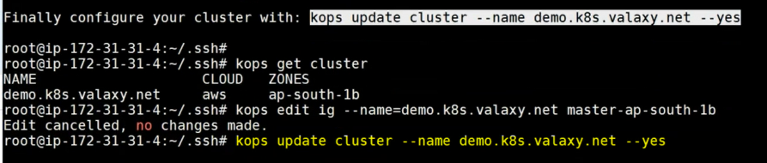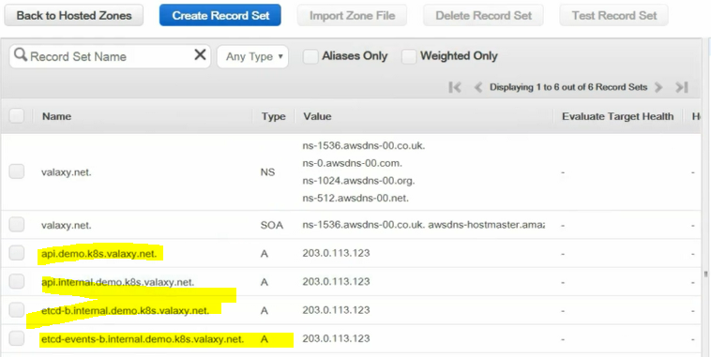

**additional routes got created and additional ec2 instances also created. Auto scale also created**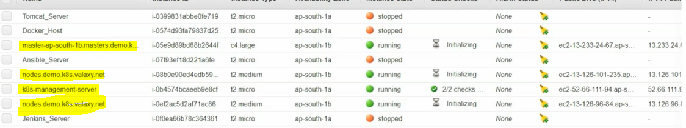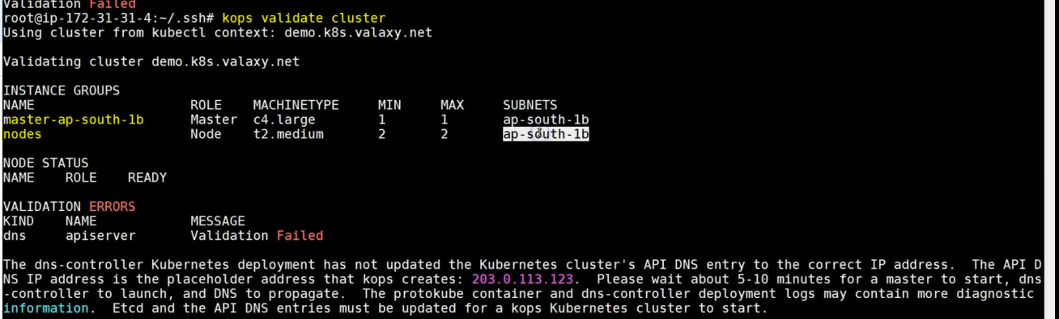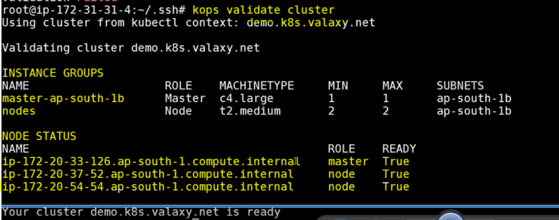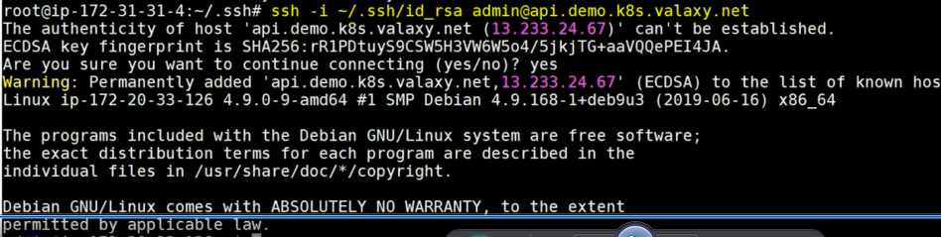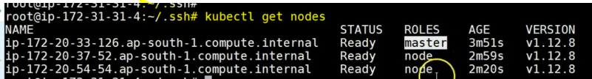

**to increases ec2 instances size will follow the below steps.** 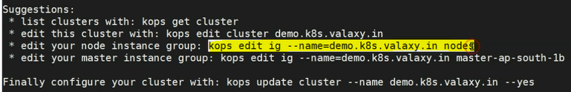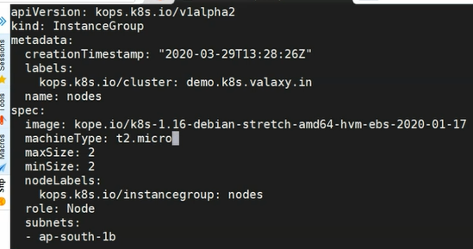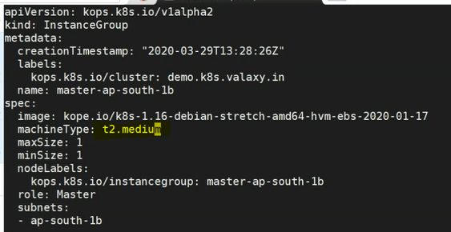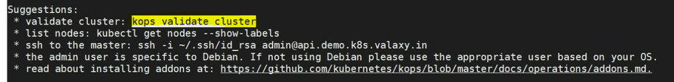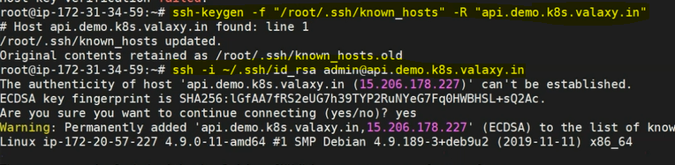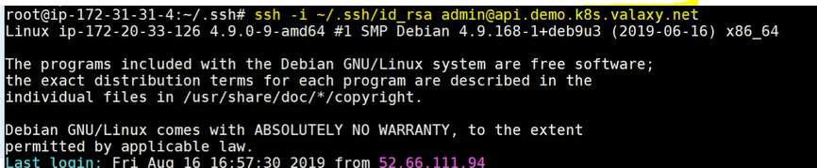

**let's login into kubernetes master machine using above command.**

**su do su -**

**to display the running nodes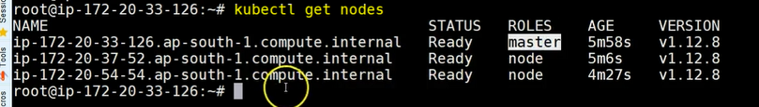to display the running prods in the server.** 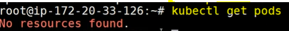

**to display the deploymentsto display the servicesdeployments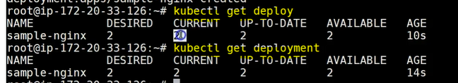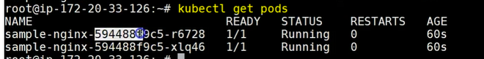it will give you more information about prods like ip and node ip information details. connect to the server using ip address: 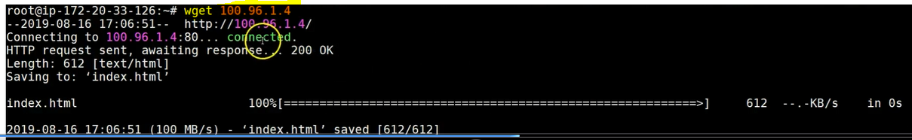creating service 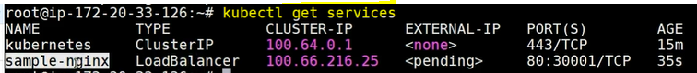once prods are available need to deployment has completed successfully or not. 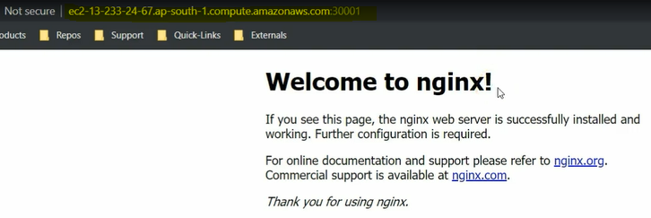deleting the prods and checking the webpage now, with in a second prods will be created again this is the magic of kubernetes. 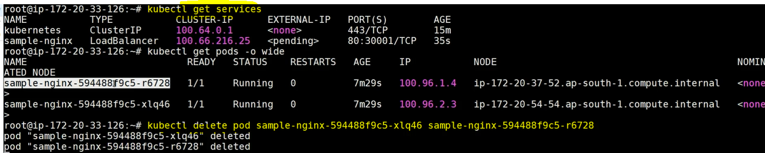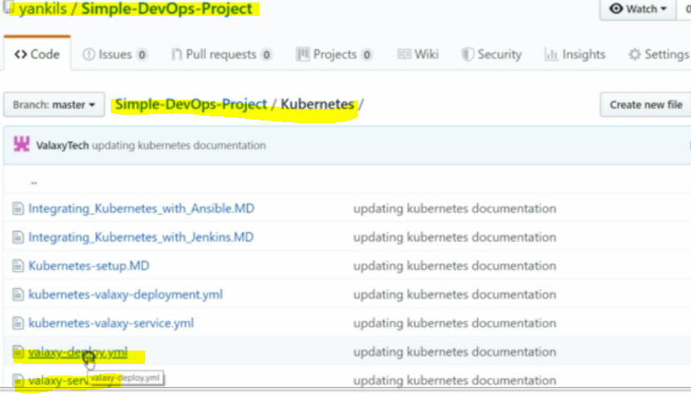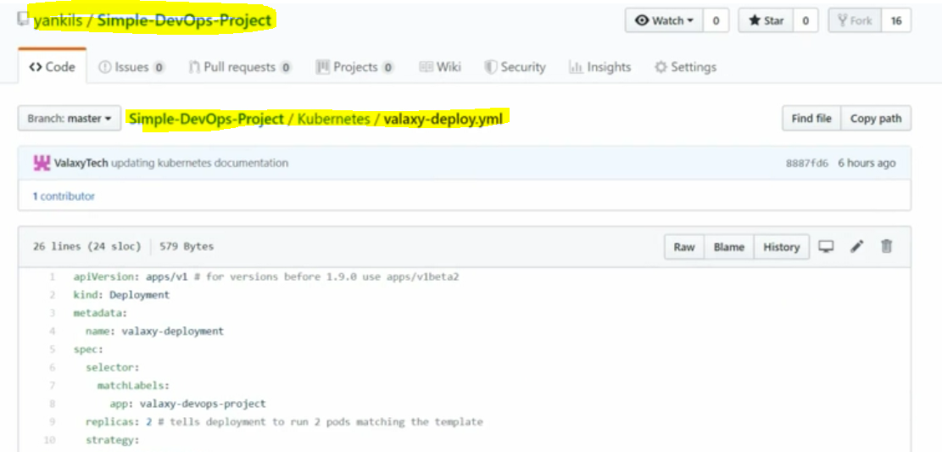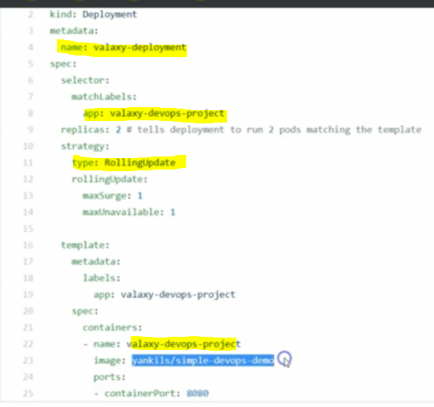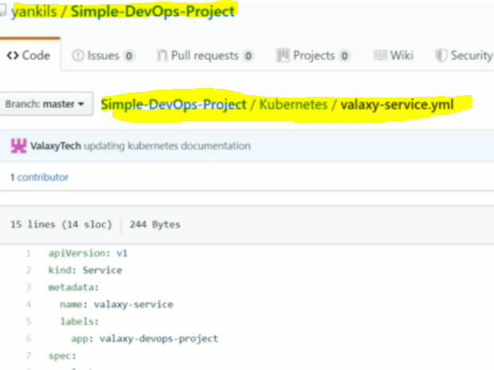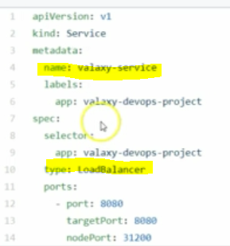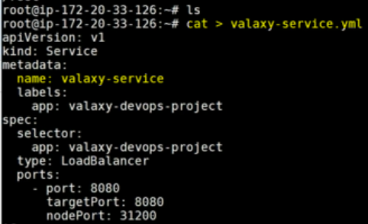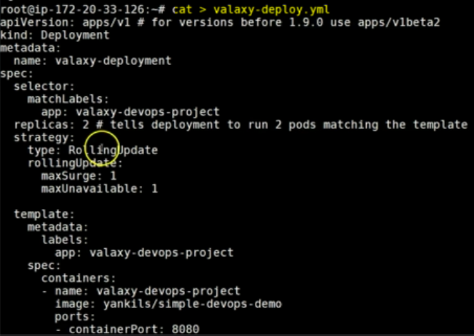removed the strategies statement for now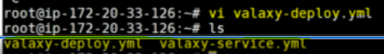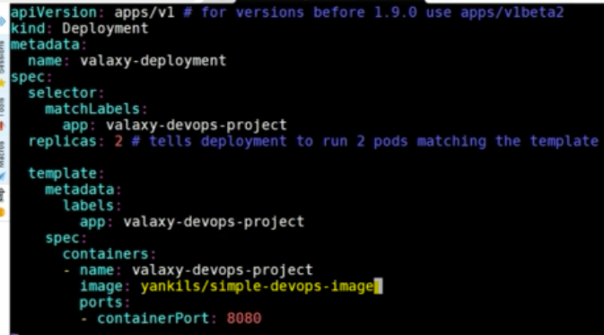running the deployment now using apply command, it will be deploy step by step 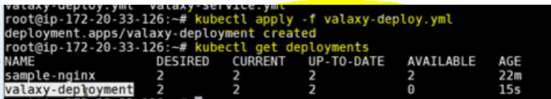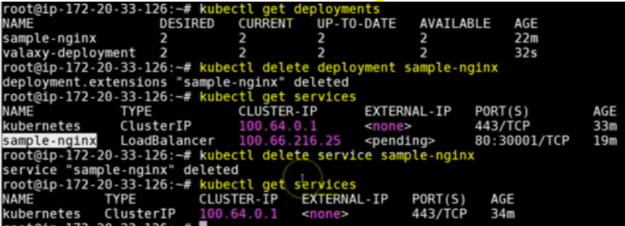creating services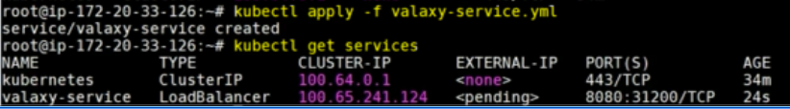open port for the ec2 instance security level for the master . 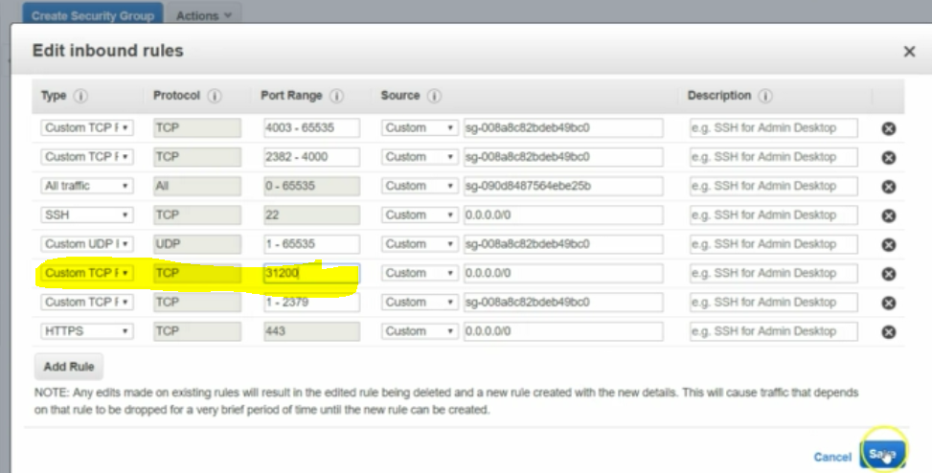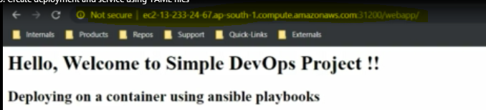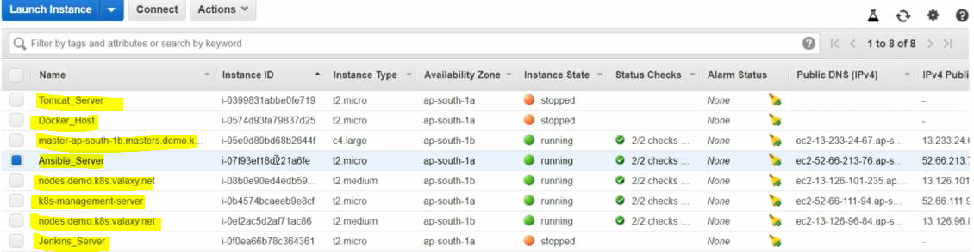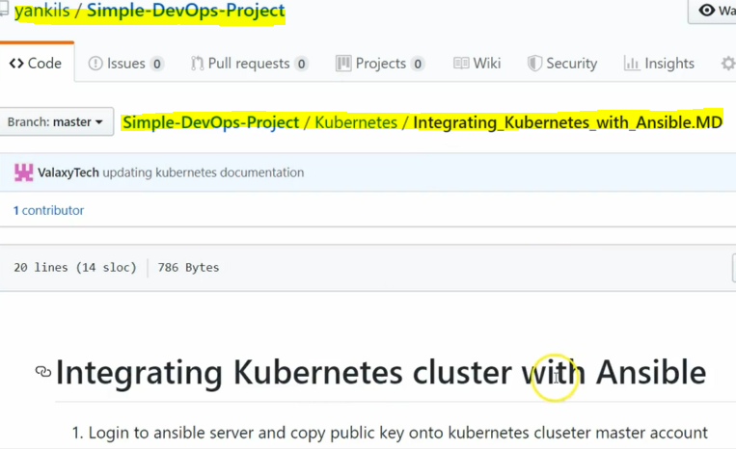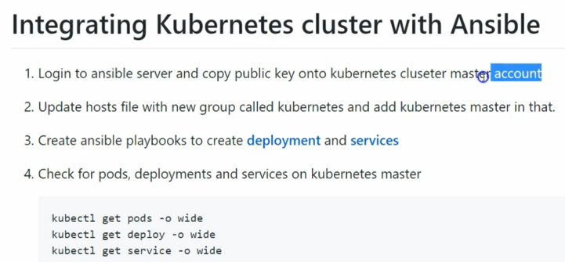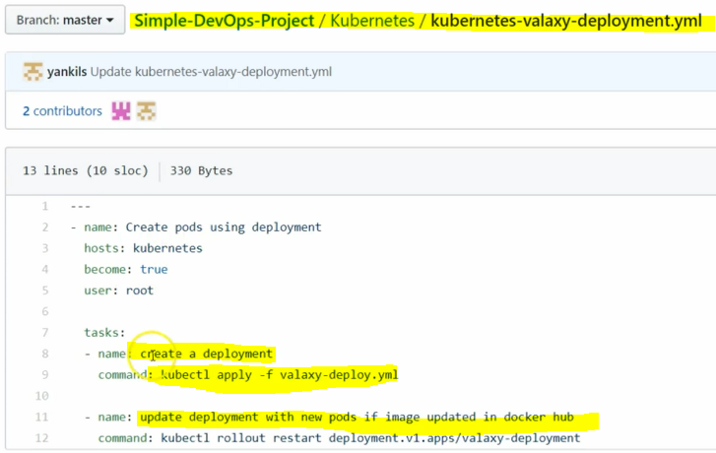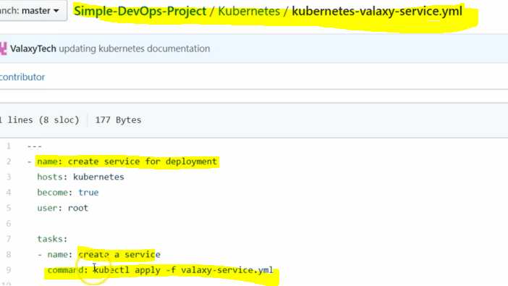login into ansible server copy and paste into kubernetes master and paste it as like below. 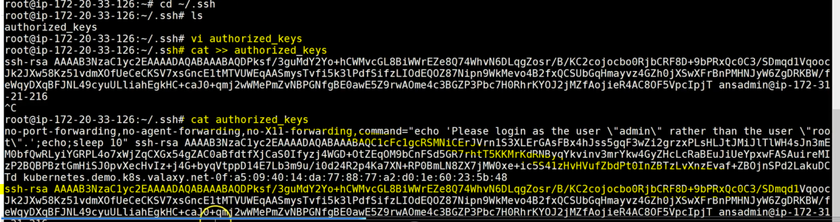from ansible server to kubernetes cluster can able to connect without password we have already configured the .ssh key to elevate the password. 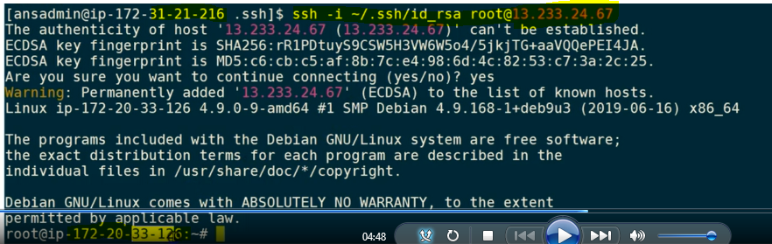 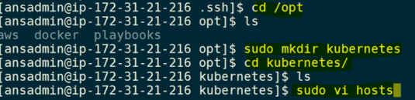 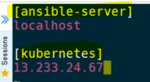  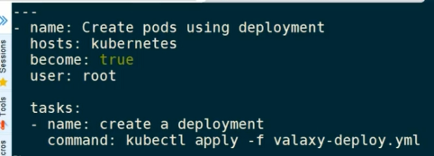  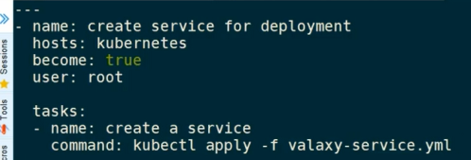now we have created host file, deployment file and serveice.yml for the CI/CD 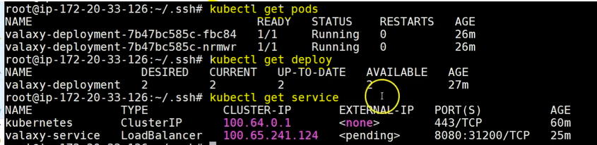deleting deployment, whenever we remove the deployment file node automatically prod node will be deleted. 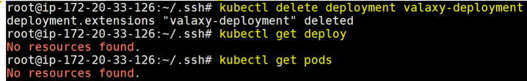 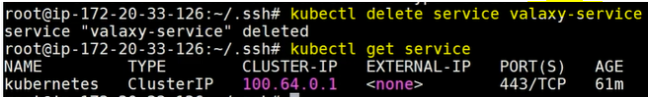run playbook in the ansible server. 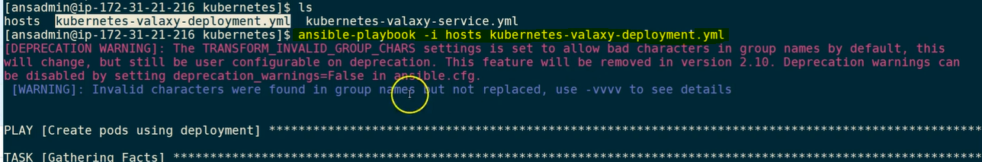check the deploy and prods created or not in the kubernetes server. 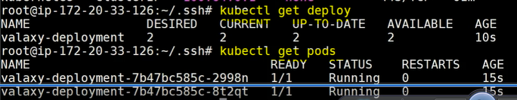 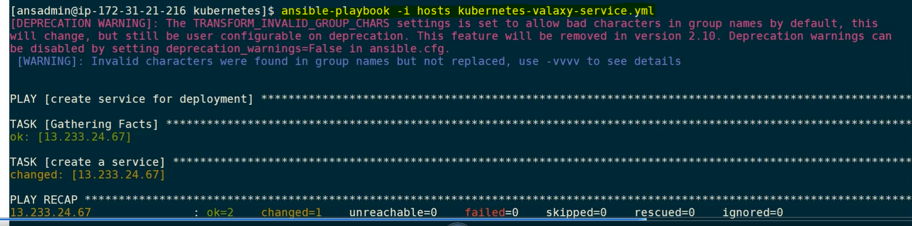 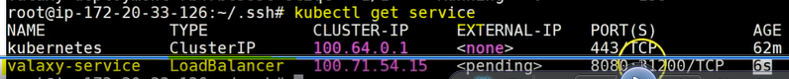check the web page working or not.** 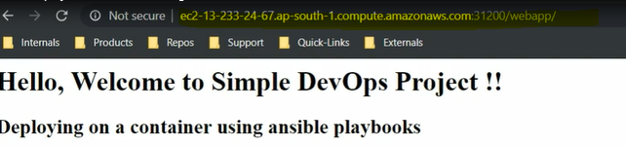

**Creating Jenkins Job for the deployment on kubernetes cluster using Ansible playbooks: 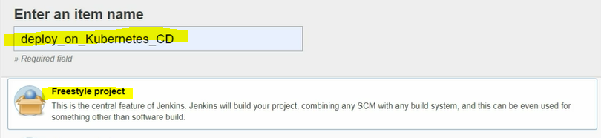 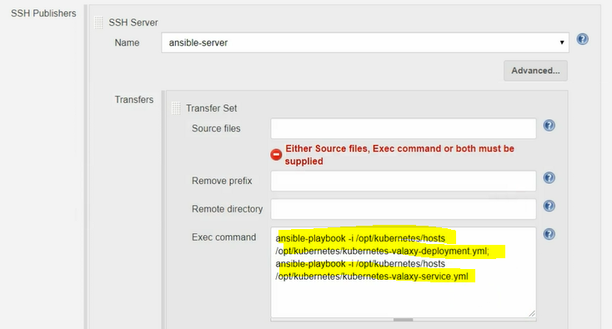 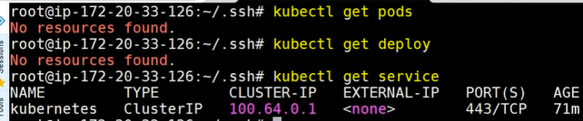now web page also won't be because of all services are not available. then start the job and check for the log file of success status and check again webpage will be working fine without any issues.**

**Create a war file and deploy into Ansible server and ansible server create an a image using playbook and deploy into a docker host as docker container but in our case need a image on kubernetes cluster. CI job will be create docker image and CD job take that image deploy into a kubernetes cluster.**

**Creating CI Jenkins job for the latest docker container. 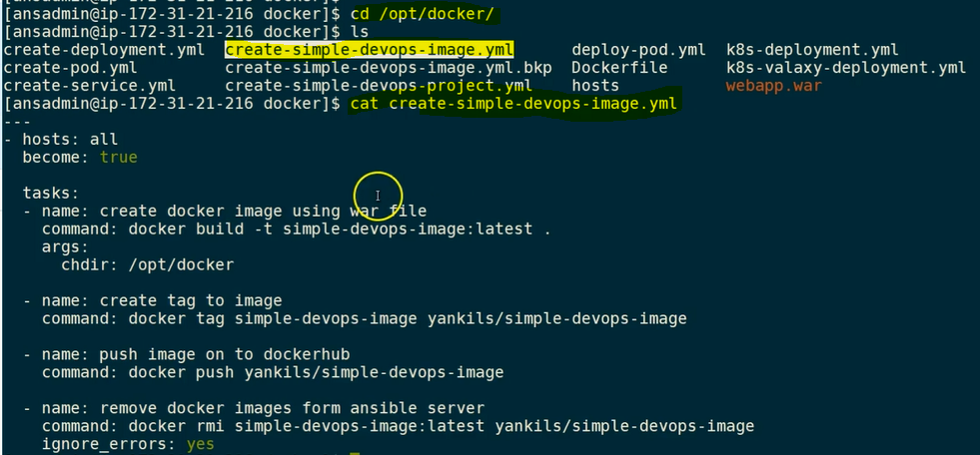 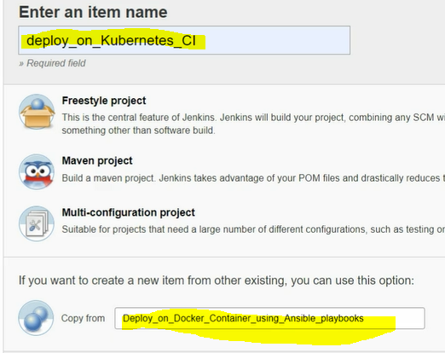 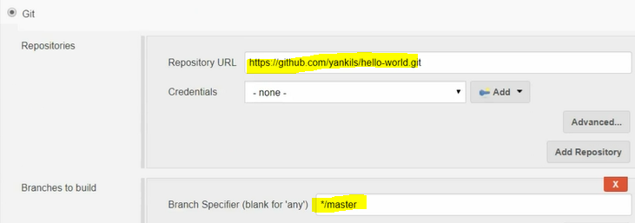 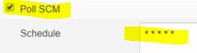 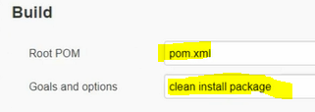 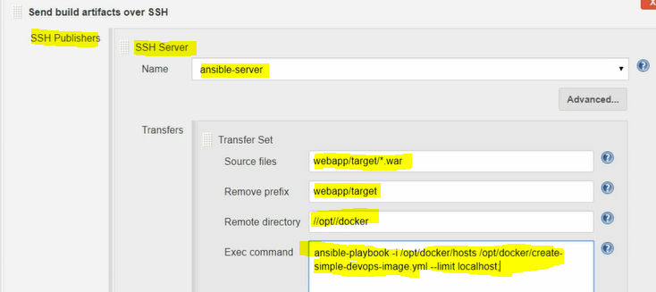save andrun the job and check the docker hub image status 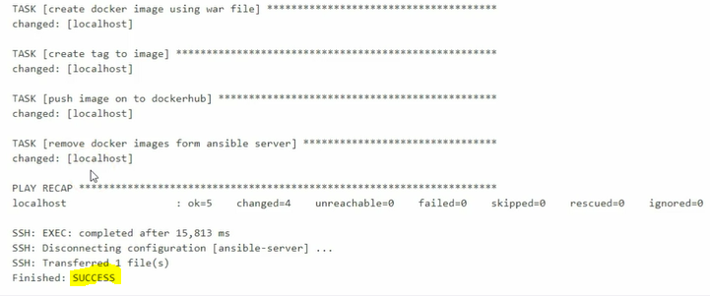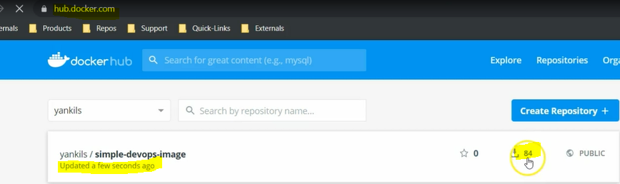 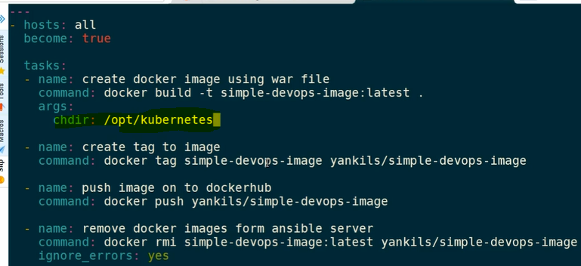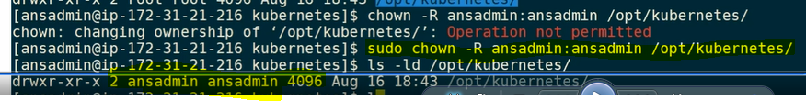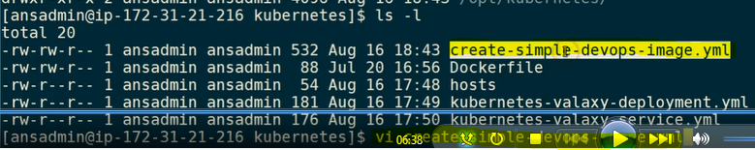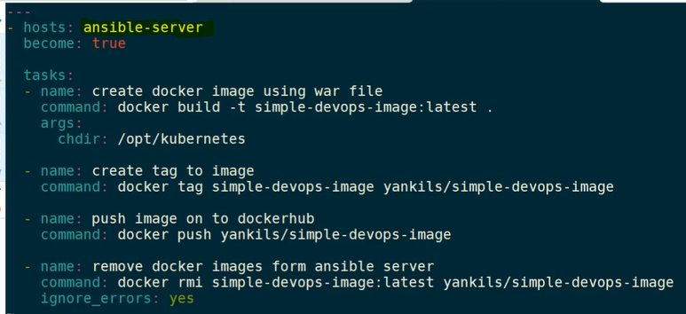 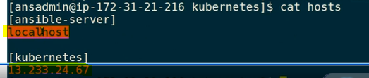 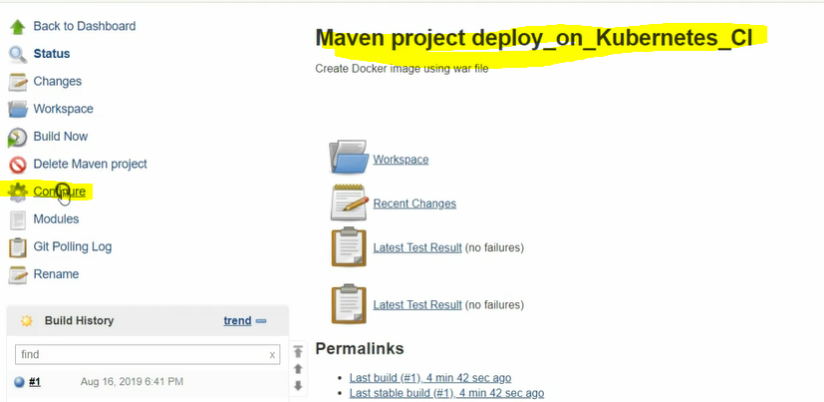 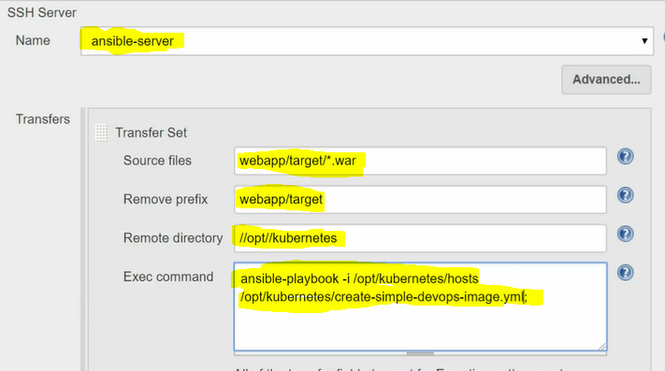save and build it and now the count will be increased in dockerhub creating dependence for the CI job for CD job**

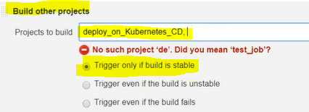 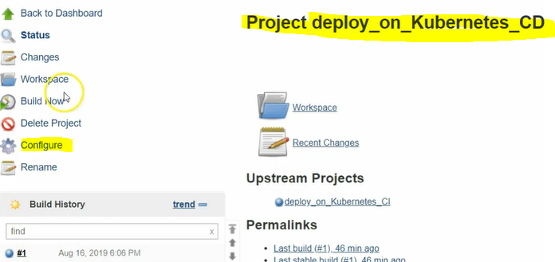 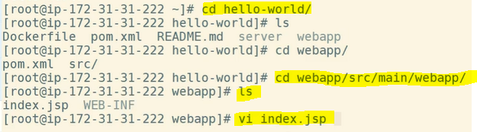  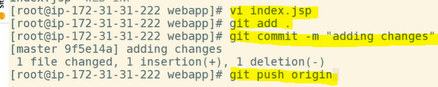

**our job will be trigger automatically using poll SCM intravel CI/CD jobs will be complete with out fail and update the docker image in the dockerhub and as well as kubernetes cluster. 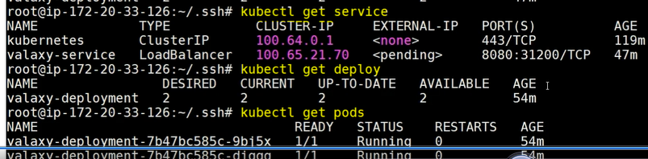Usually if there is any change if can't able to pull the image until directly to enabled the versioning.**

**Enabling roll out restart option in our all ansible playbooks. 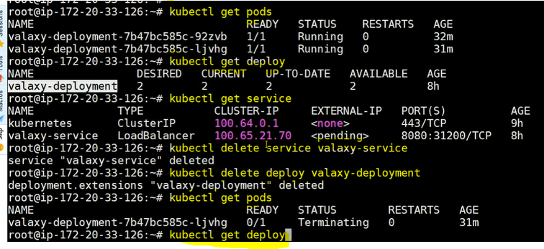 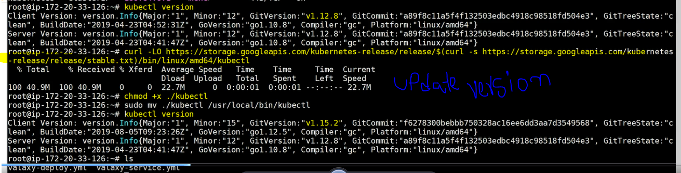rollout restart feature adding in the playbook** 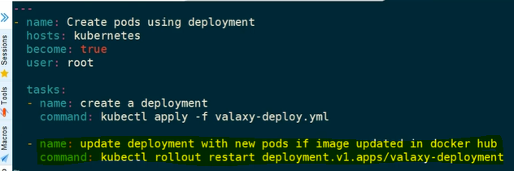

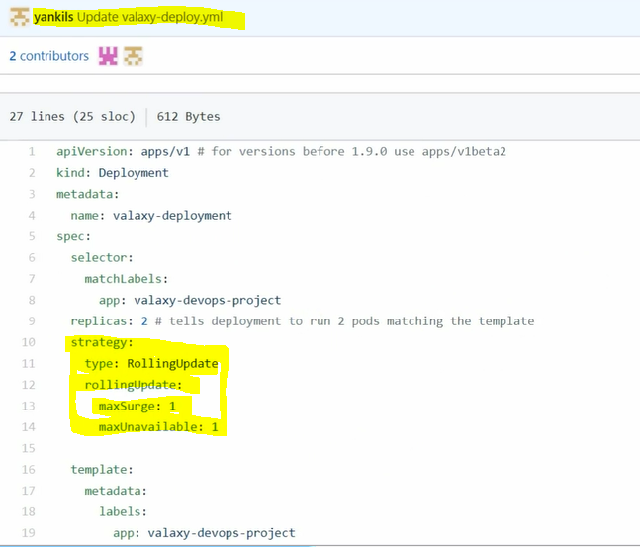 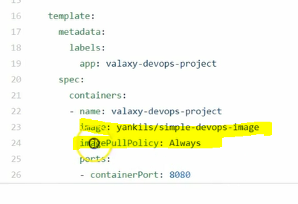

**rolling update strategy and imagepullpolicy should be always then only our images automatically deploy into kubernetes prods without restart each and every time.both yml files need to add rollout and restart features in the yml files in real time senarios.  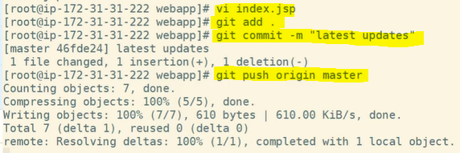the job will be automatically start and deploy the images into dockerhub and kubernetes clusters without any manual intervention.** 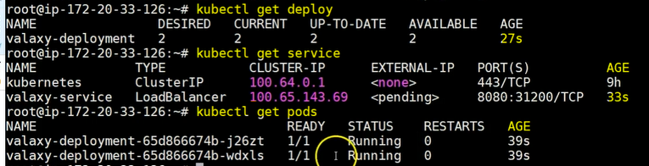 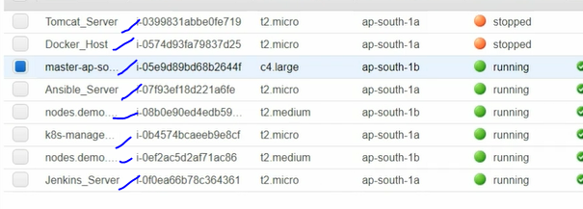 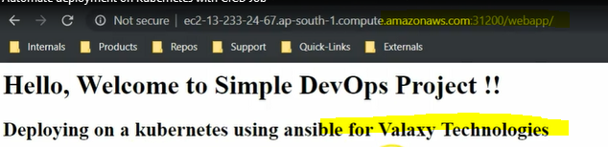 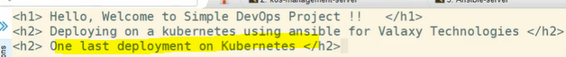 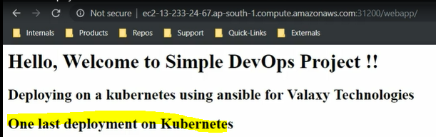 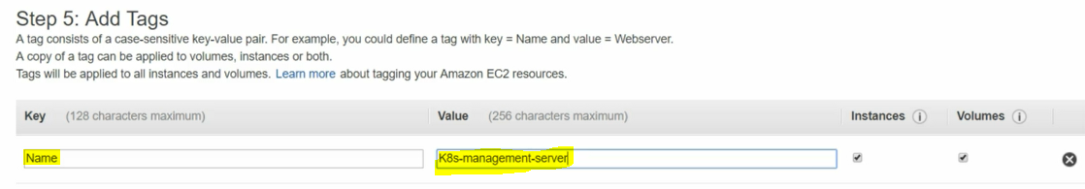

**Kubernetes server tag name 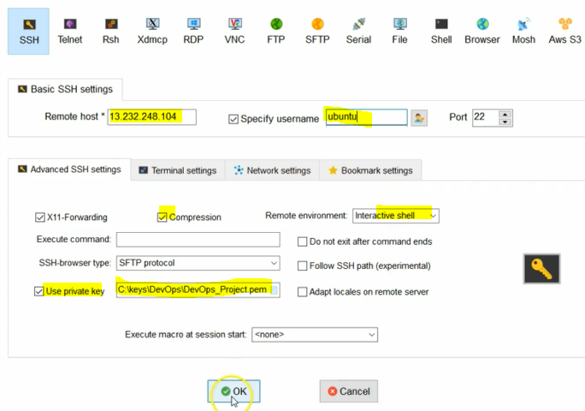 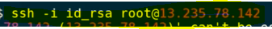after ssk key added into remote server test the connection command 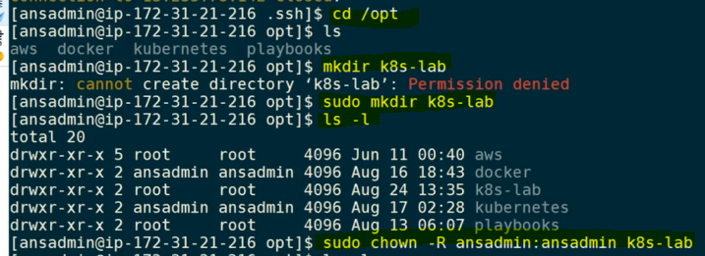giving permission for the k8s-lab directory access for user ansadmin user. 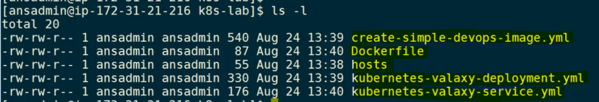 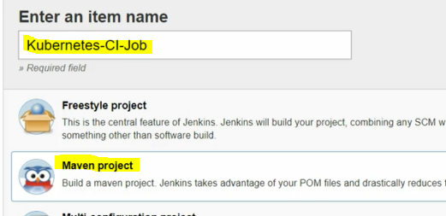 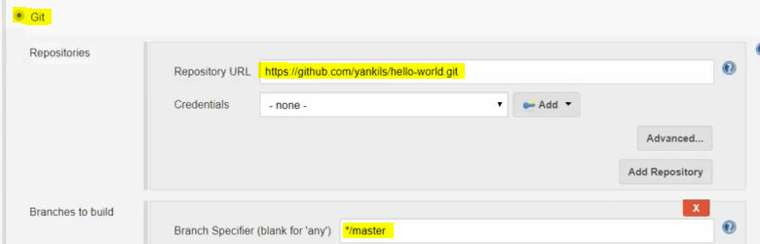 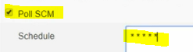 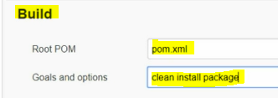 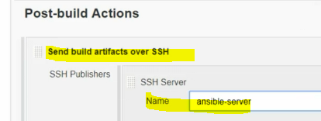 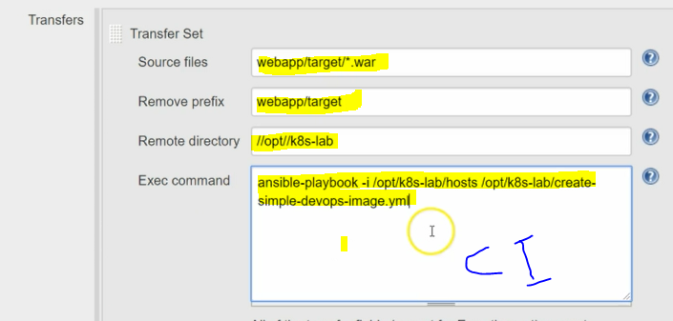 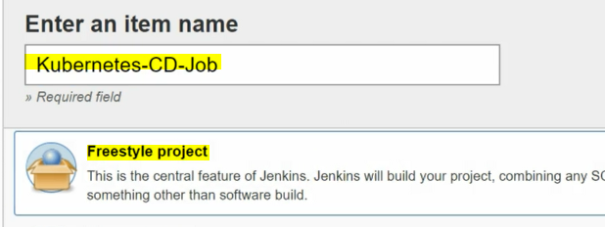 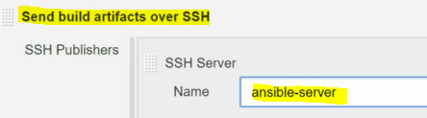 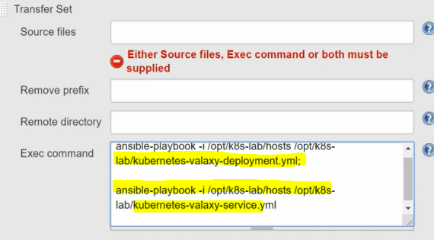save 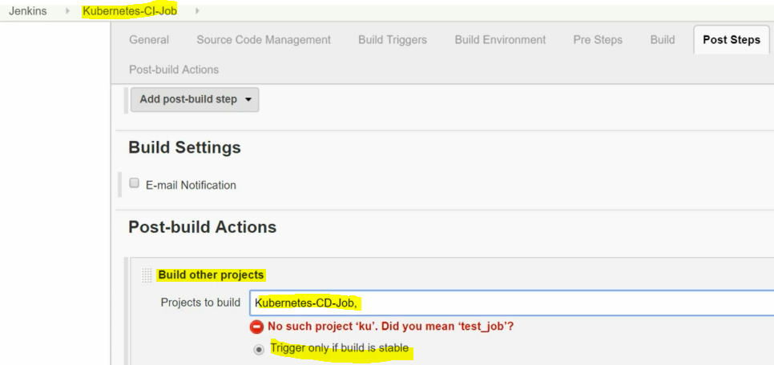before running jobs check the kubernetes services are running or not. 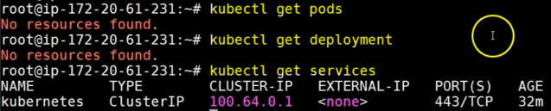now execute the job. And check the kubernetes prods, deployments and services** 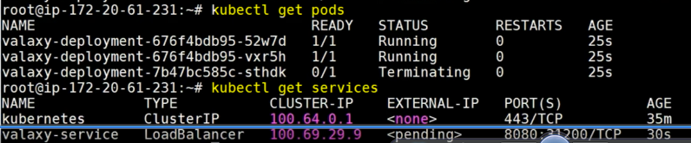 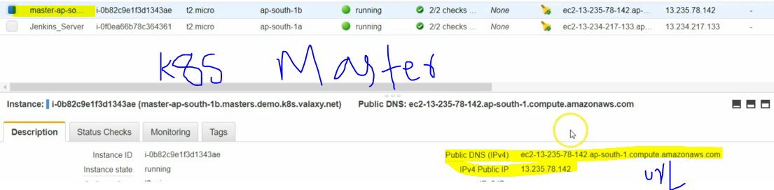 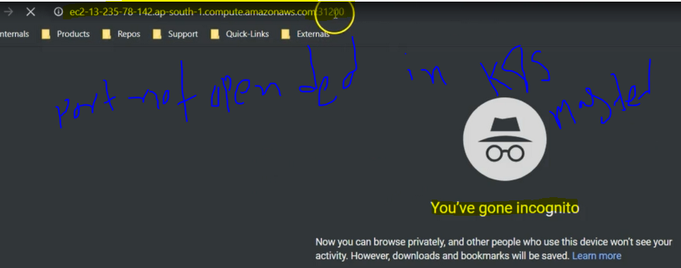 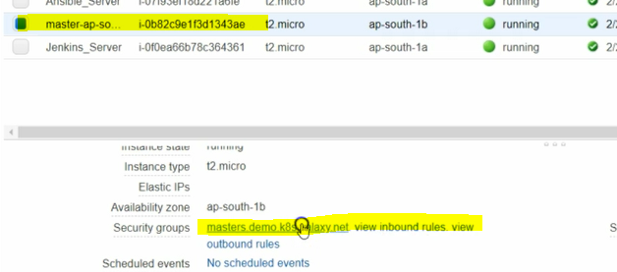 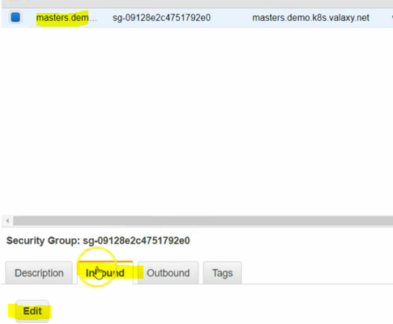 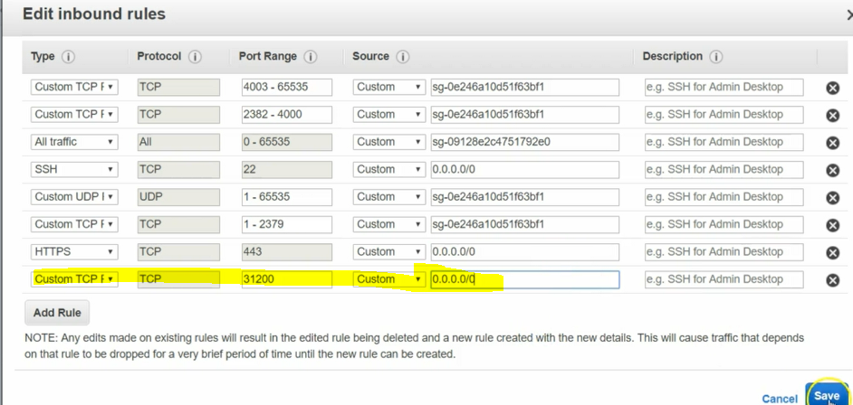 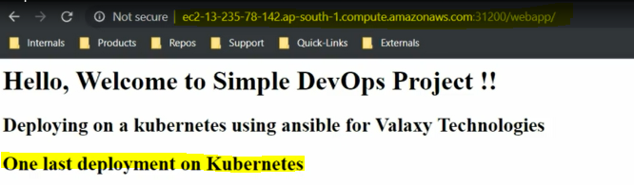

**change the source code and update and restart the job now again for the rechecking. now fully completed CI/CD job**